Cover Page

Table of Contents

1. ETL Overview 2

1.1. Why ETL? 2

1.2. Benefits of ETL 2

1.3. How ETL Works 2

2. Data Warehouse 3

2.1. Relationship between Data Warehouse and ETL 3

2.2. Relationship between OLAP and ETL 3

3. AWS Glue 4

3.1. What AWS Glue Does 4

3.2. How AWS Glue Works 4

3.3. Features and Benefits 5

4. Creating an Amazon AWS Account 6

5. IAM Permissions Setup 18

6. Amazon S3 Storage 23

7. Creating AWS Glue Data Catalog 30

8. Building Visual ETL Jobs 42

9. Amazon Redshift Setup 49

10. Final Output 60

Works Cited 62

# ETL Overview

ETL stands for Extract, Transform, Load. It is a process commonly used in data warehousing and analytics to move data from various sources, transform it into a consistent format, and load it into a target database or data warehouse for analysis and reporting purposes (Amazon Web Services, n.d.).

## Why ETL?

ETL is essential for several reasons:

1. **Data Integration:** It enables organizations to integrate data from multiple sources, such as databases, applications, and external systems, into a unified format (Amazon Web Services, n.d.).
2. **Data Quality:** ETL processes often include data cleansing and validation, enhancing the accuracy and consistency of the data (Amazon Web Services, n.d.).
3. **Performance:** By transforming and optimizing data before loading it into the target system, ETL helps improve query performance and overall efficiency (Amazon Web Services, n.d.).
4. **Scalability:** ETL processes are scalable and capable of handling large volumes of data, making them suitable for enterprise-level data processing needs (Amazon Web Services, n.d.).

## Benefits of ETL

1. **Improved Data Quality:** ETL processes help identify and correct errors, duplicates, and inconsistencies in data, leading to higher data quality (Amazon Web Services, n.d.).
2. **Increased Efficiency:** By automating the extraction, transformation, and loading of data, ETL reduces manual effort and saves time (Amazon Web Services, n.d.).
3. **Enhanced Business Intelligence:** ETL enables organizations to consolidate and analyze data from multiple sources, providing valuable insights for decision-making (Amazon Web Services, n.d.).

## How ETL Works

The ETL process typically involves three main steps:

1. **Extract:** In this step, data is extracted from various sources, such as databases, files, APIs, or external systems. This can involve querying databases, reading files, or using APIs to retrieve data. The extracted data is then staged in a temporary storage area, such as a staging database or file system (Amazon Web Services, n.d.).
2. **Transform:** Once the data is extracted, it undergoes transformation to convert it into a consistent format suitable for analysis and reporting. This transformation process may include cleaning, filtering, aggregating, joining, or enriching the data. Additionally, data may be normalized or denormalized to ensure consistency and efficiency (Amazon Web Services, n.d.).
3. **Load:** After transformation, the data is loaded into the target database or data warehouse. This involves writing the transformed data to the target tables or files in the desired format. The load process may include various optimization techniques to improve performance, such as partitioning, indexing, or parallel processing (Amazon Web Services, n.d.).

# Data Warehouse

## Relationship between Data Warehouse and ETL

Data warehousing and ETL (Extract, Transform, Load) are intricately linked in the realm of data management and analytics. ETL serves as a fundamental process in populating and maintaining data warehouses. In ETL, data is first extracted from various sources, such as databases, files, or applications. This extracted data is then transformed into a consistent format, ensuring uniformity and enhancing its usability for analysis. Finally, the transformed data is loaded into the data warehouse, where it becomes readily accessible for reporting, querying, and analysis (Amazon Web Services, n.d.).

Data warehouses serve as centralized repositories for storing and managing large volumes of structured and sometimes semi-structured data. They are designed to support complex queries and analytics operations efficiently. ETL processes play a crucial role in feeding data into these warehouses, ensuring that the data is cleansed, integrated, and organized in a manner conducive to effective analysis. Thus, the relationship between data warehouses and ETL is symbiotic, with ETL serving as a critical component in the lifecycle of data within a data warehousing environment (Oracle, n.d.)

## Relationship between OLAP and ETL

OLAP (Online Analytical Processing) is closely intertwined with ETL processes within the context of data warehousing and analytics. OLAP facilitates complex multidimensional analysis of data, allowing users to explore data along various dimensions and hierarchies dynamically. ETL processes contribute to OLAP by preparing and shaping the data stored within the data warehouse to optimize it for OLAP analysis (IBM, n.d.)

ETL involves transforming raw data into a structured format suitable for analysis and reporting. This transformation may include tasks such as aggregating data, creating hierarchies, and pre-calculating summary measures. These transformations are essential for OLAP, as they enable efficient querying and exploration of data across different dimensions and levels of granularity. Without the preparatory steps performed by ETL processes, OLAP analysis would be significantly hampered by the complexity and heterogeneity of raw data (Talend, n.d.)

In essence, ETL acts as a precursor to OLAP, laying the groundwork by transforming and organizing data within the data warehouse to facilitate meaningful and insightful analysis. By aligning the data structure with OLAP requirements, ETL enables users to leverage the full capabilities of OLAP tools for interactive and exploratory data analysis (Azure Analysis Services, n.d.)

# AWS Glue

AWS Glue is a fully managed extract, transform, and load (ETL) service provided by Amazon Web Services (AWS). It offers a serverless environment for preparing and loading data into data lakes and data warehouses for analysis (AWS, n.d.)

## What AWS Glue Does

AWS Glue simplifies the process of building and managing ETL workflows by providing a managed service that automates many of the tedious tasks associated with data preparation. Its primary functionalities include:

* Providing a managed environment for building and executing ETL workflows (AWS, n.d.)
* Automatically discovering and cataloging data, making it easier to analyze (AWS, n.d.).
* Defining ETL jobs using a visual interface or by writing custom code in Python or Scala (AWS, n.d.).

## How AWS Glue Works

AWS Glue operates in the following manner:

* Data discovery is automated through crawlers that scan data sources and populate the Glue Data Catalog with metadata (AWS, n.d.).
* Users define ETL jobs, specifying data sources, targets, and transformation logic (AWS, n.d.).
* AWS Glue orchestrates the execution of ETL jobs, handling data extraction, transformation, and loading tasks (AWS, n.d.).

## Features and Benefits

AWS Glue offers several features and benefits, including:

* Flexible support for all workloads including ETL, ELT, batch, streaming, and more, with no lock-in. (AWS, n.d.)
* Automatic scaling to handle varying workloads, ensuring high performance while only charging users for the compute resources consumed during job execution. (AWS, n.d.)
* Supports both visual and code-based development approaches, allowing users to choose the method that best suits their skill level and requirements. (AWS, n.d.)
* Fully managed service, eliminating the need for users to provision, configure, and manage infrastructure providing complete data integration capabilities in one serverless service. (AWS, n.d.)

# Creating an Amazon AWS Account

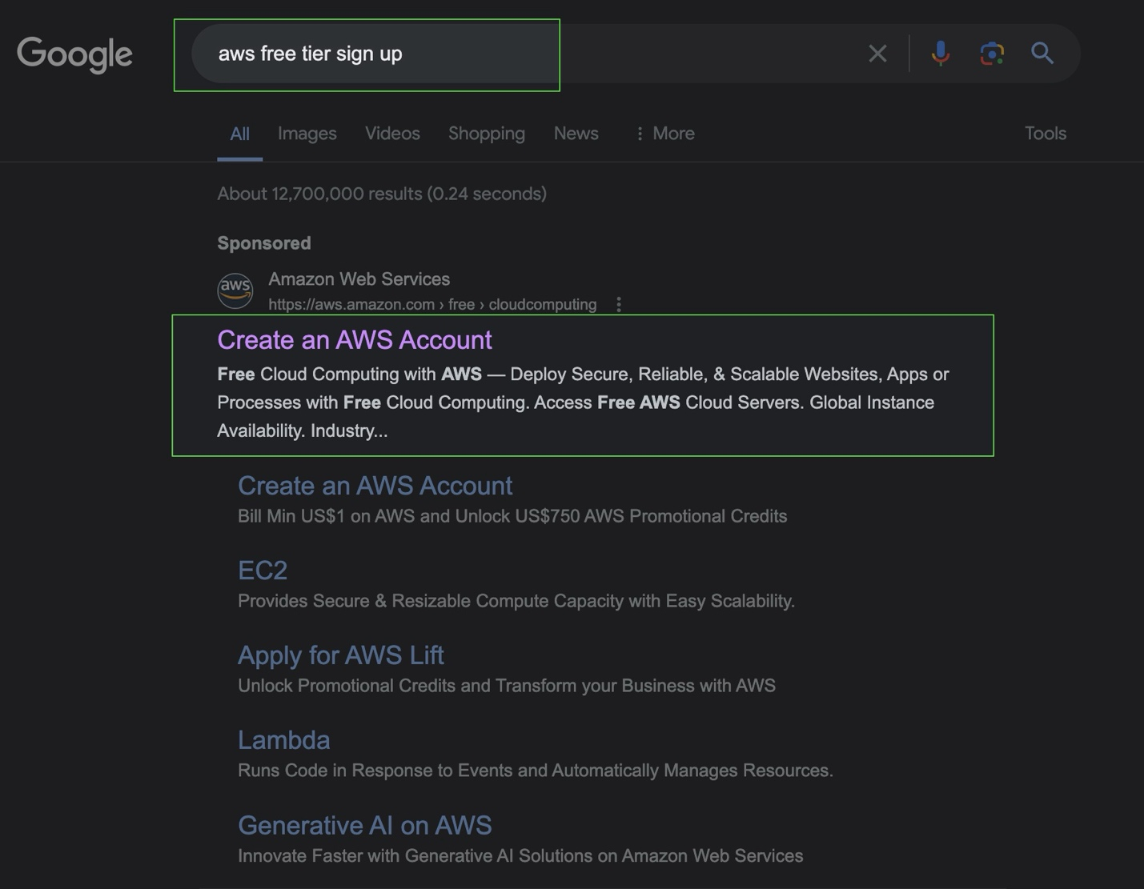

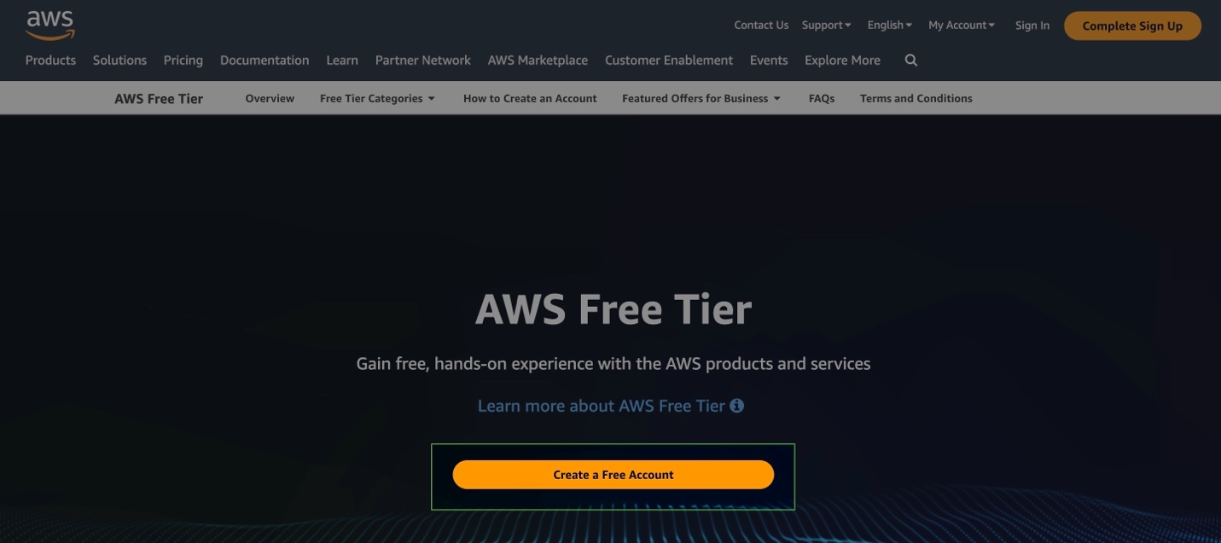

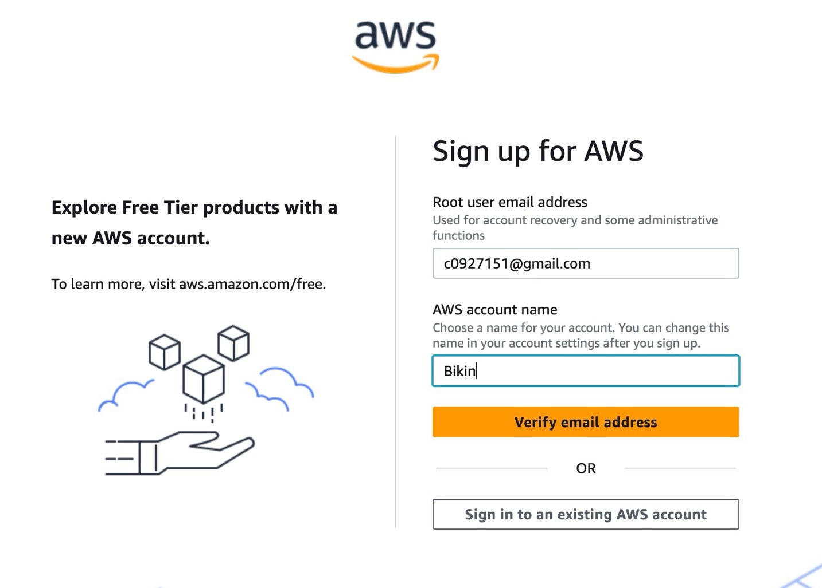

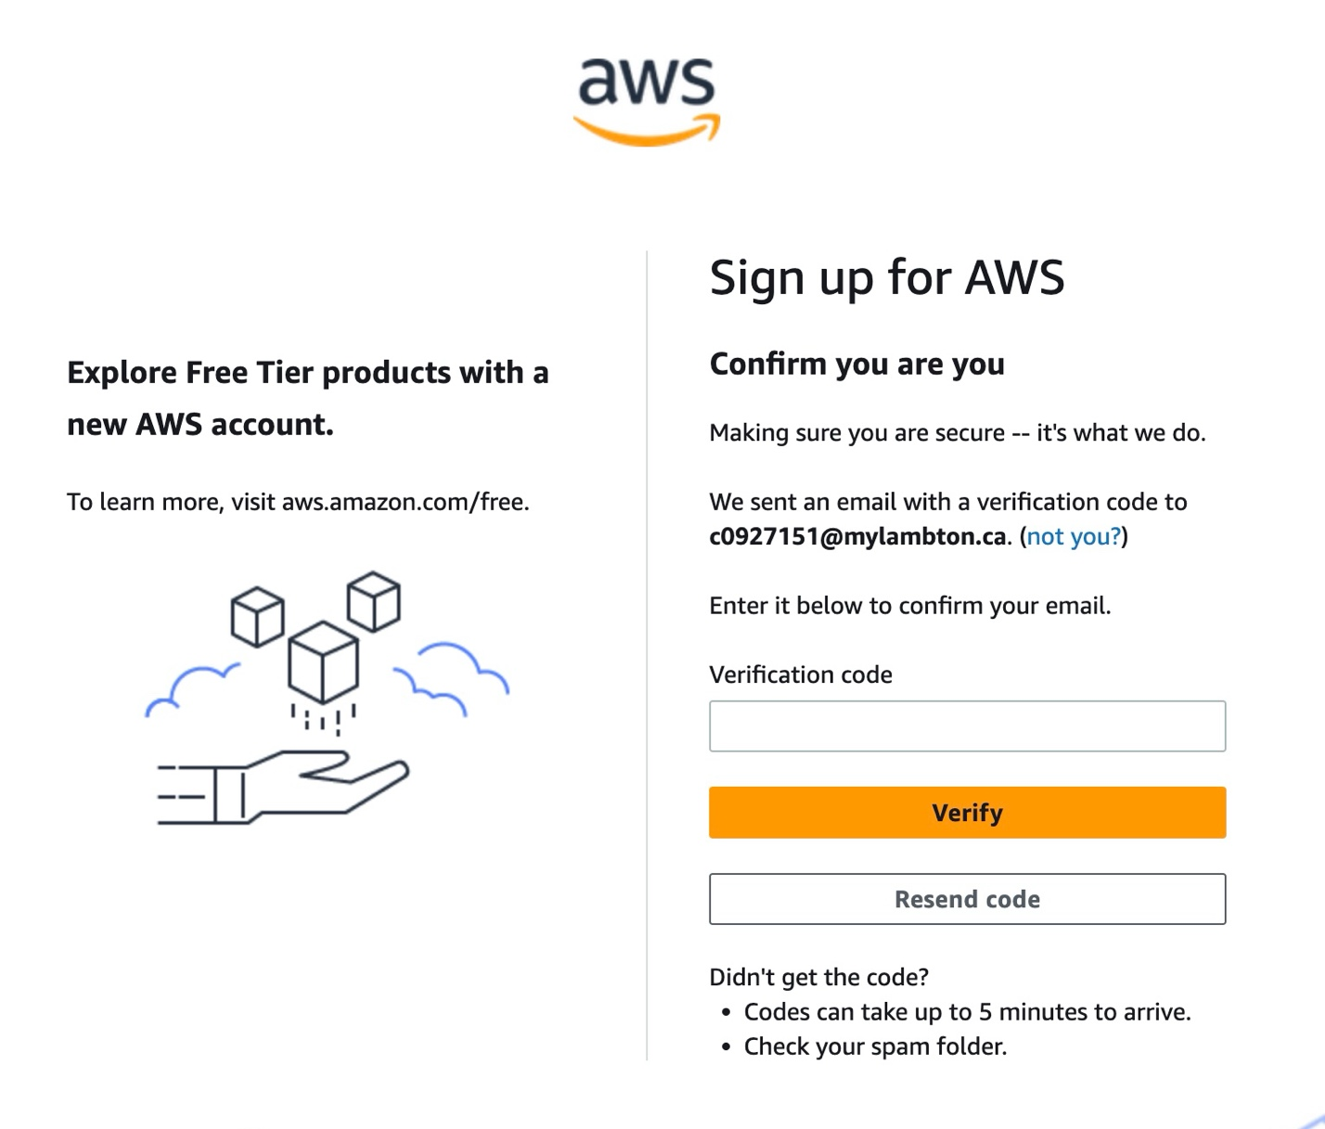

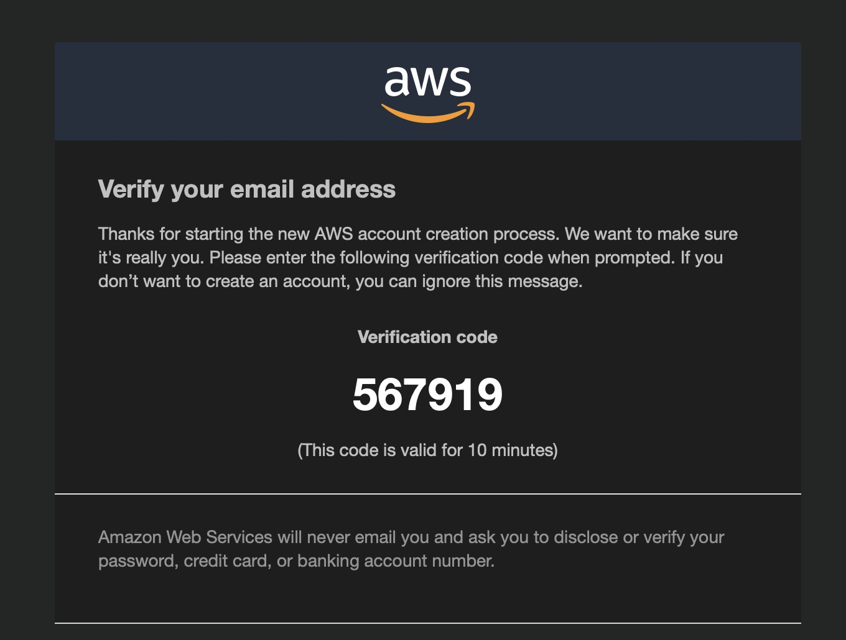

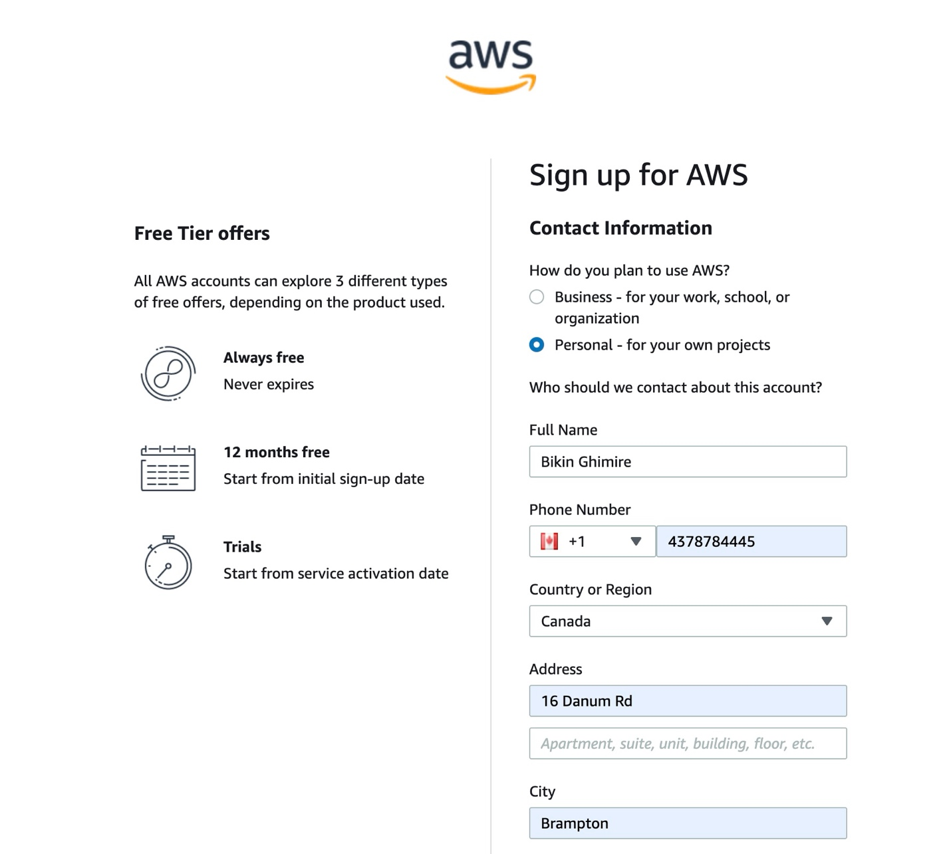



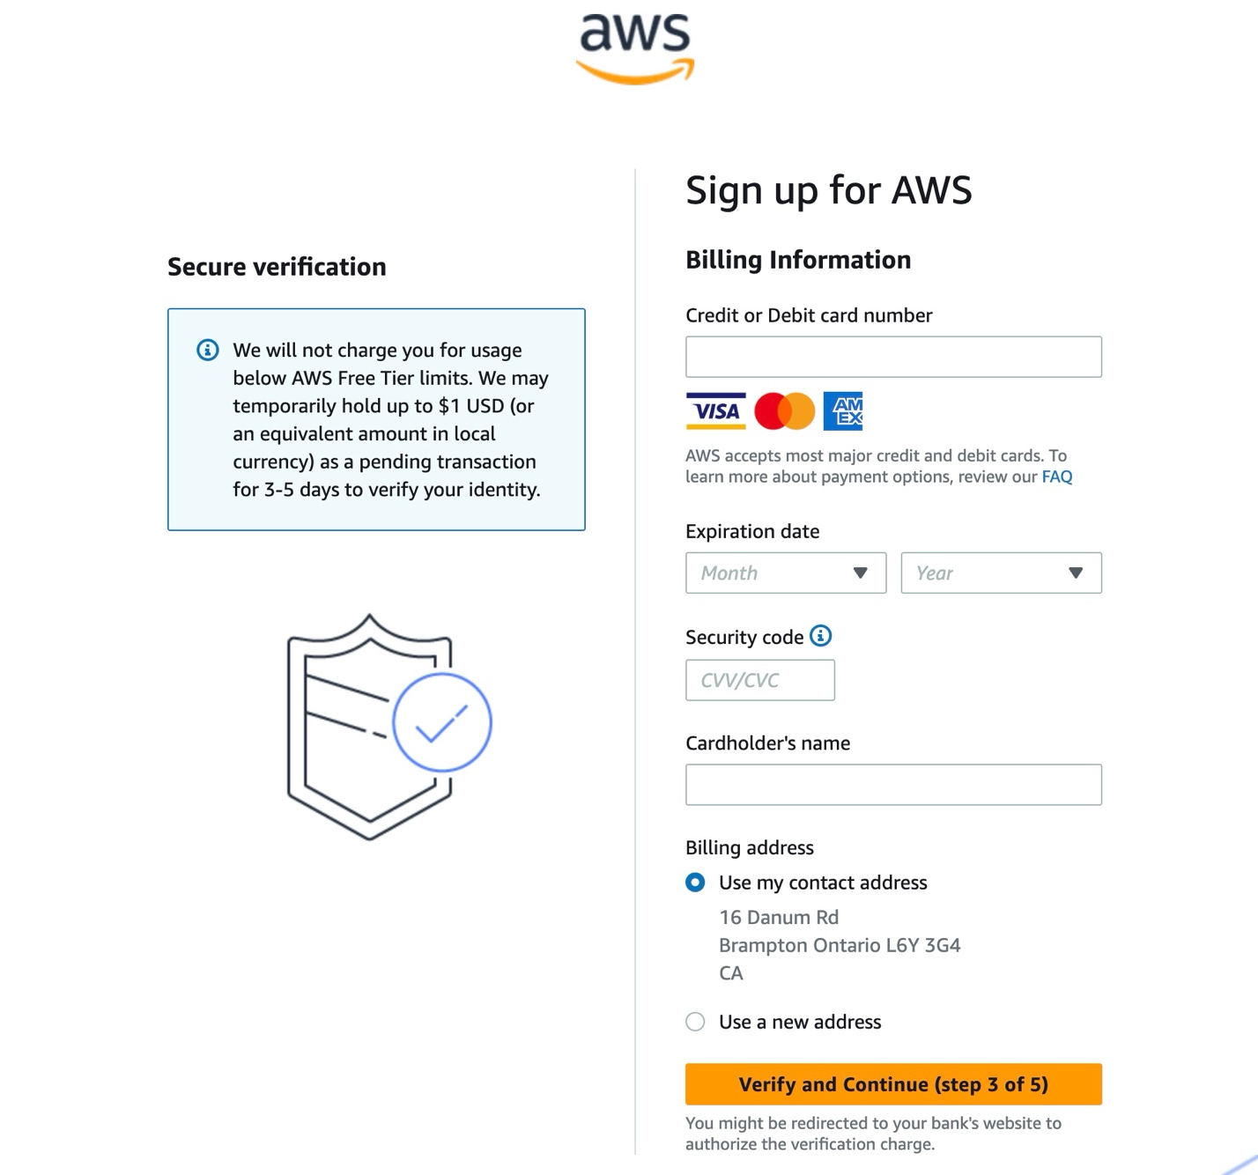





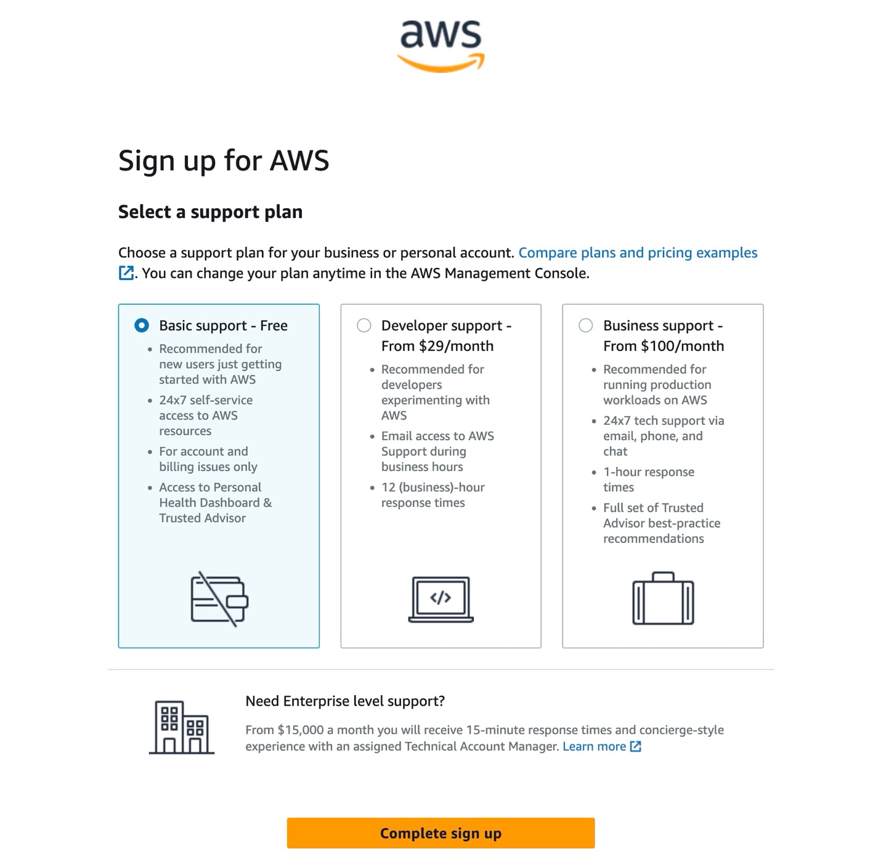

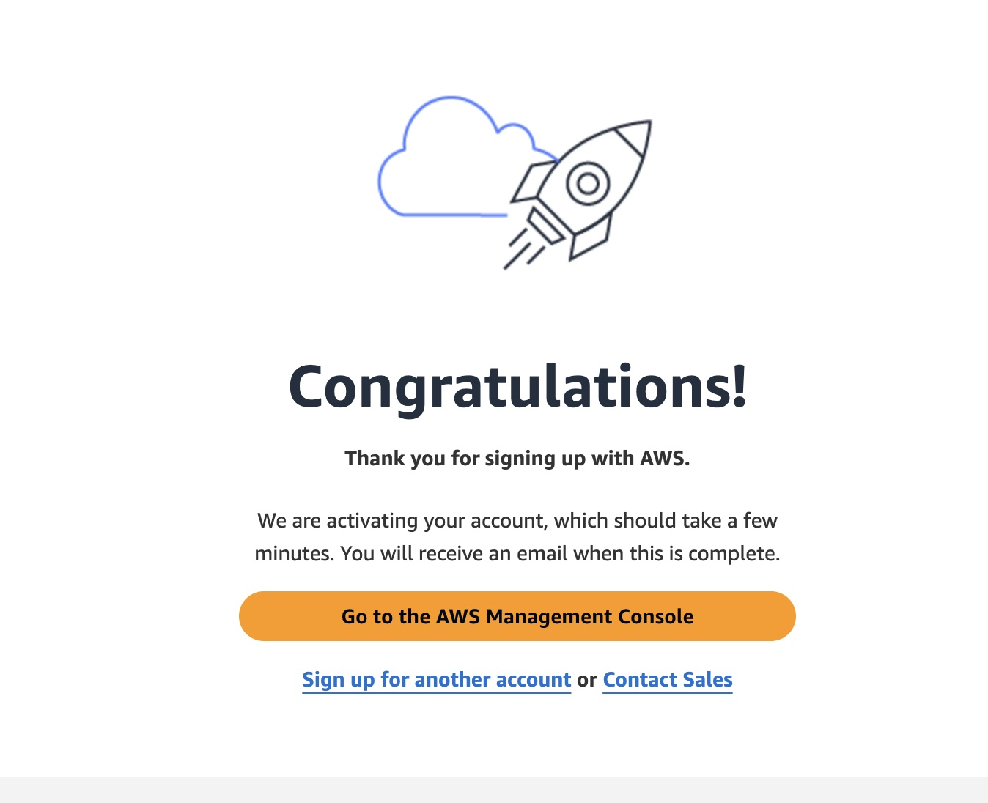





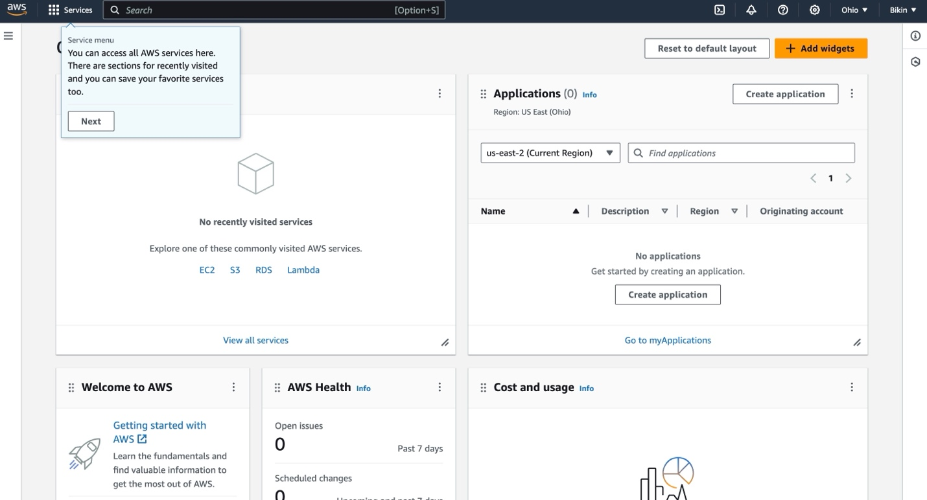

# IAM Permissions Setup

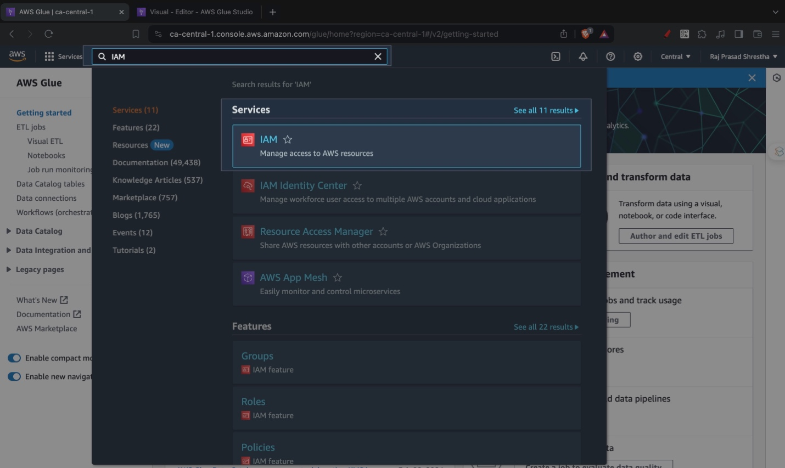

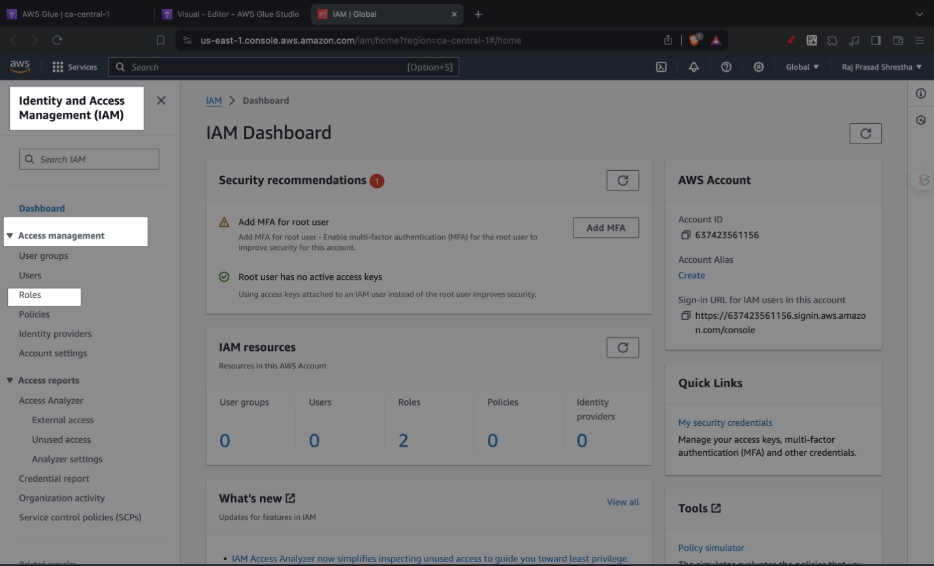

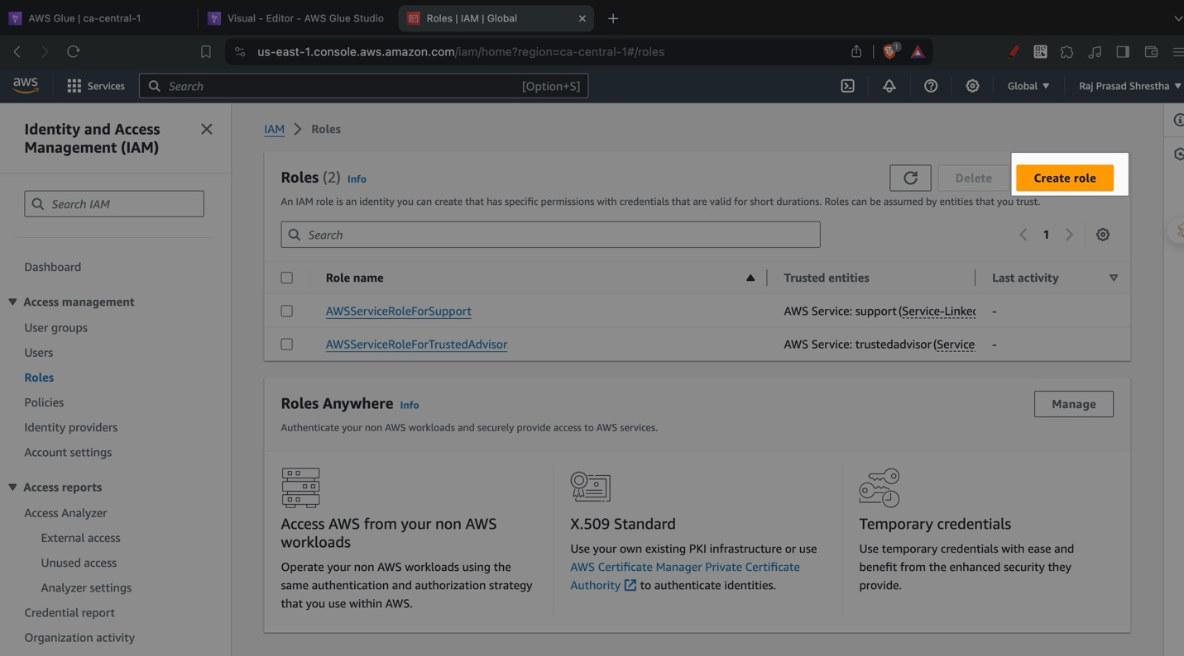

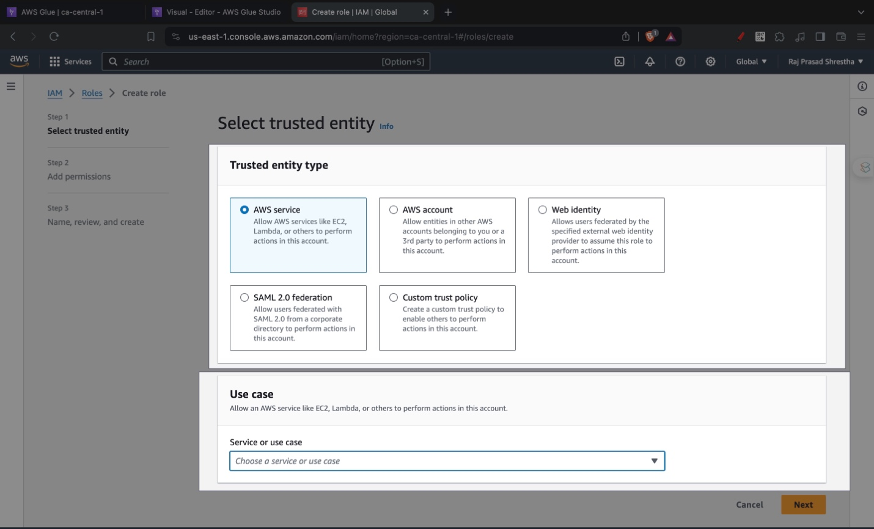

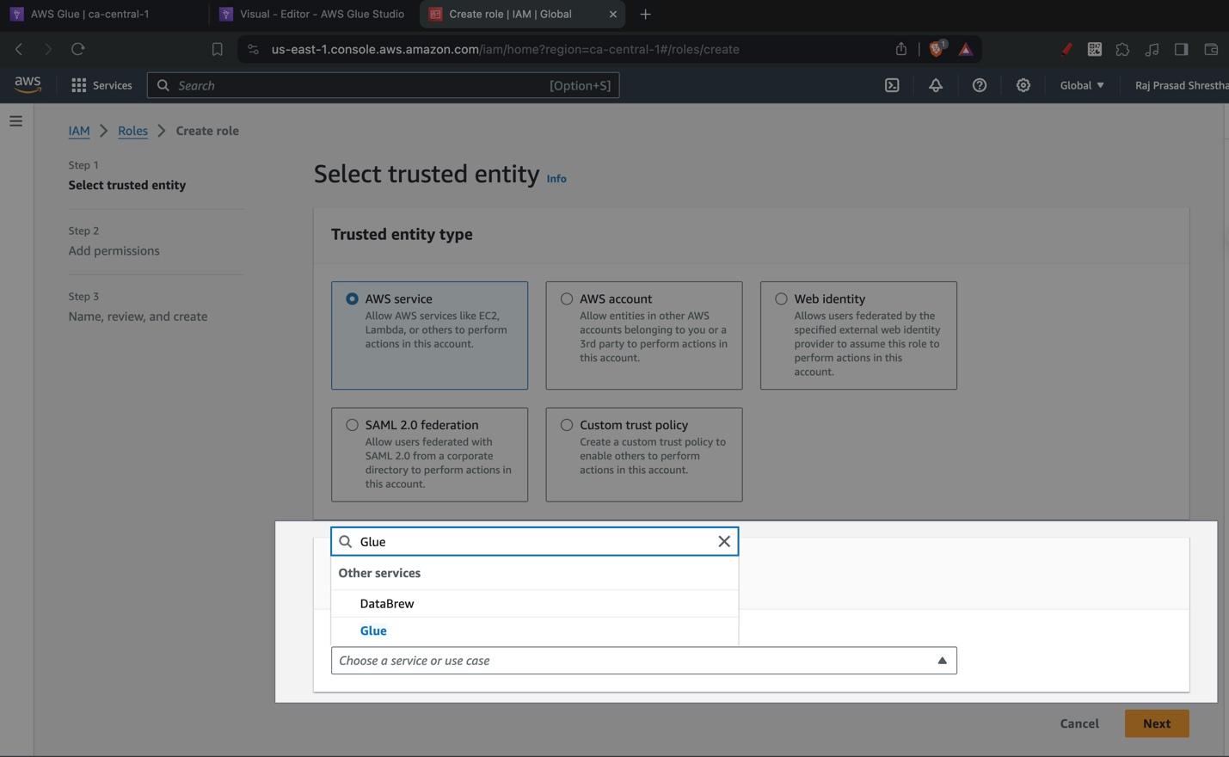

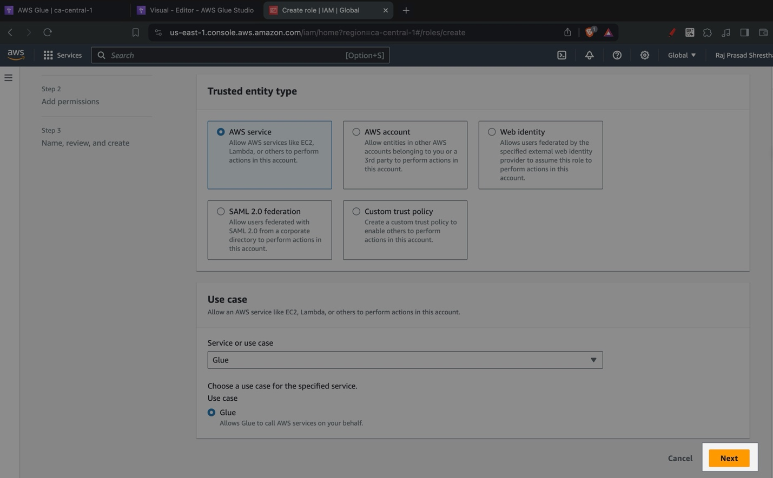

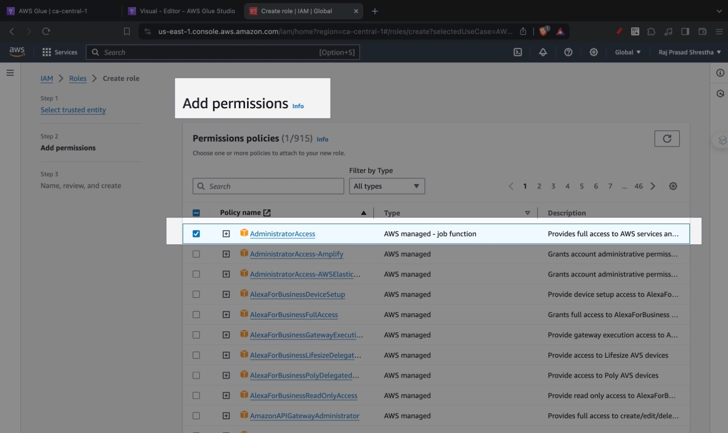

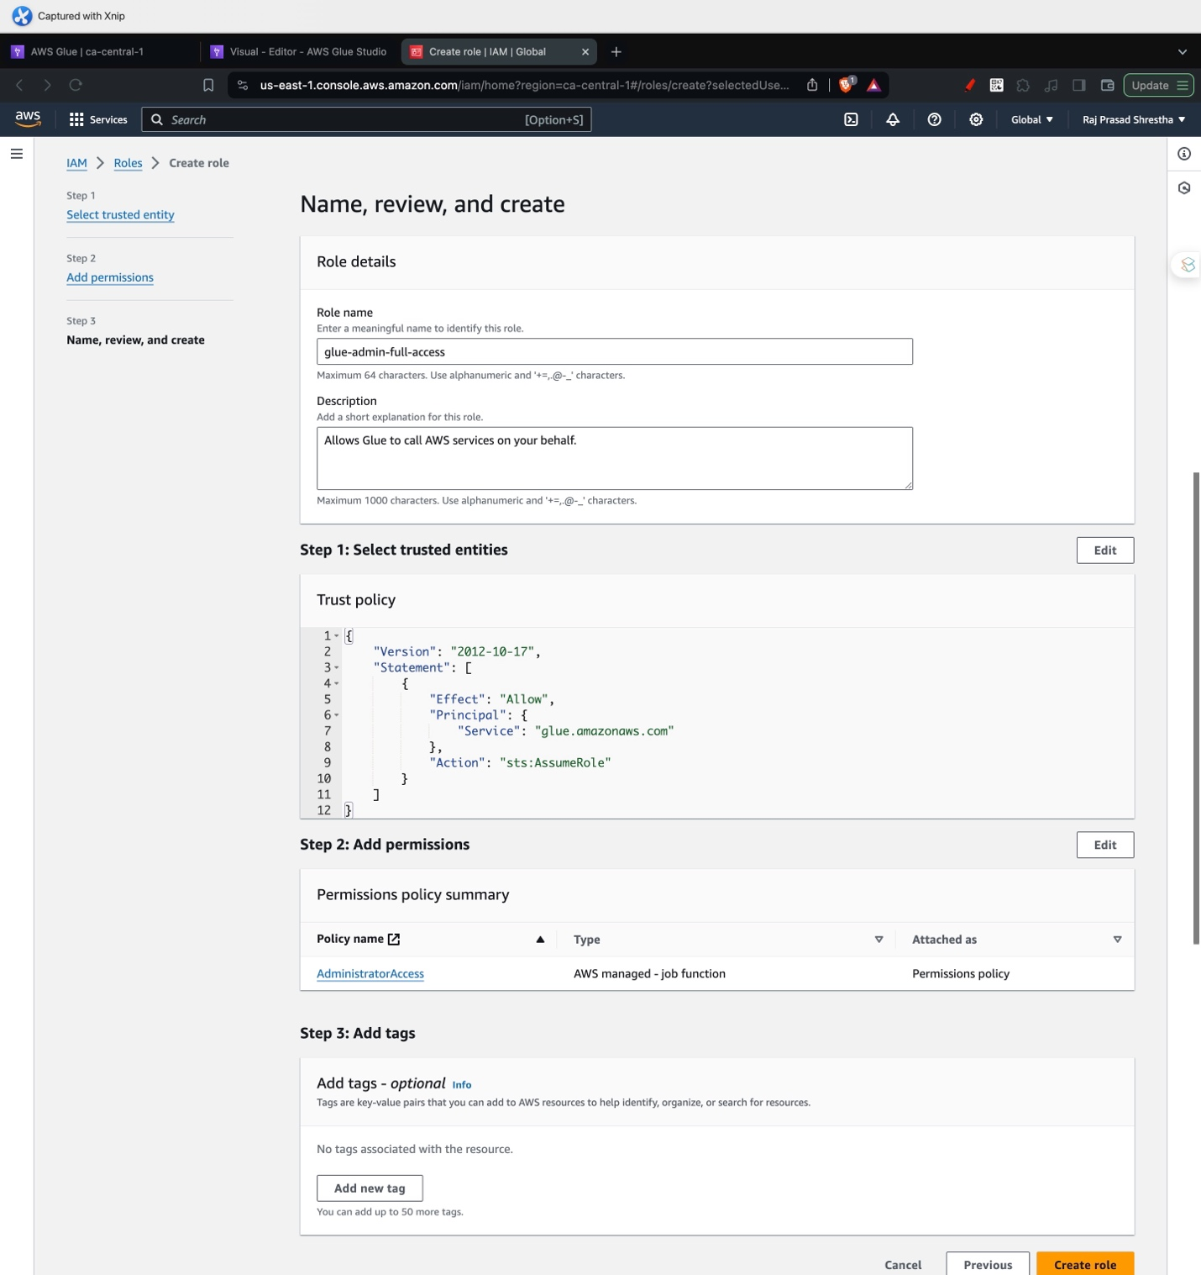

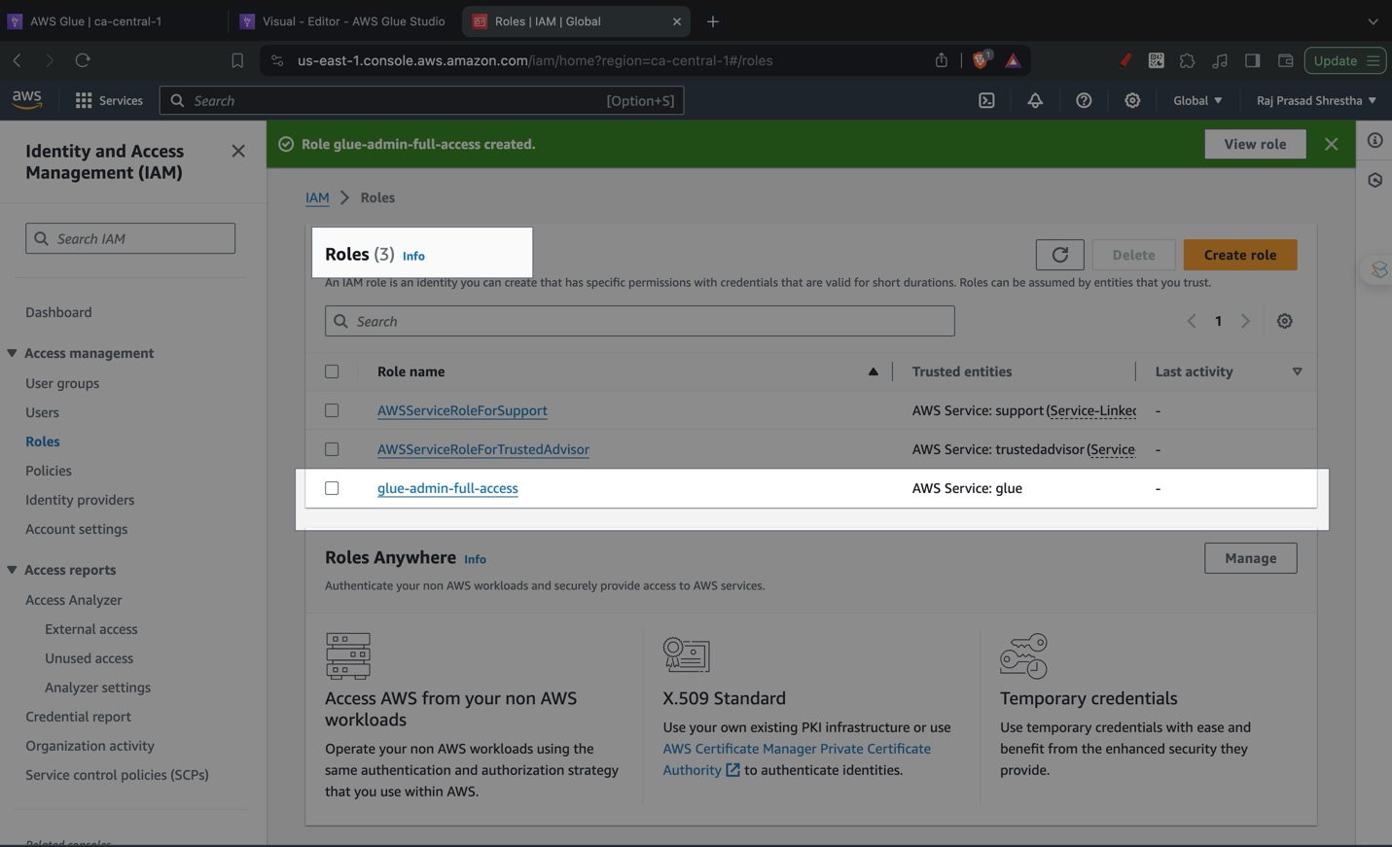

# Amazon S3 Storage

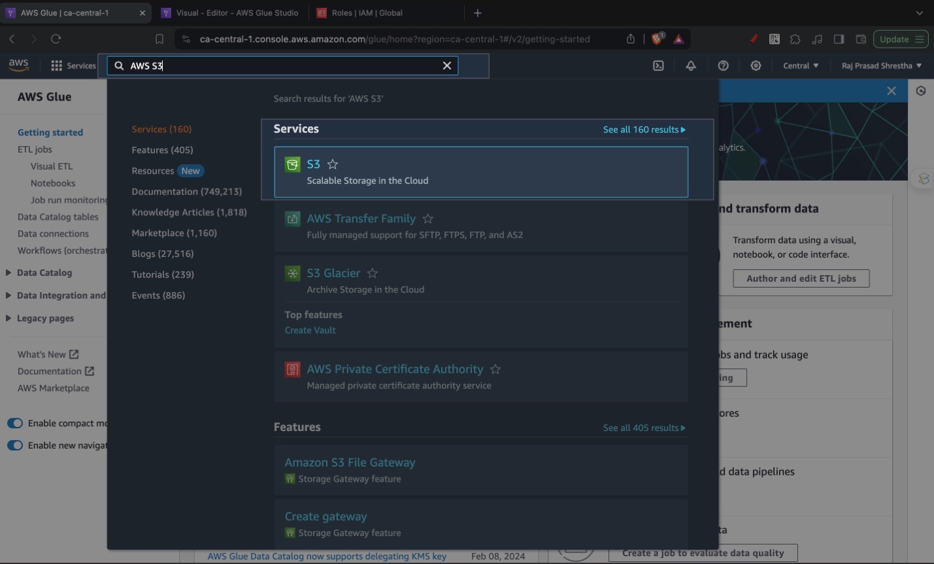

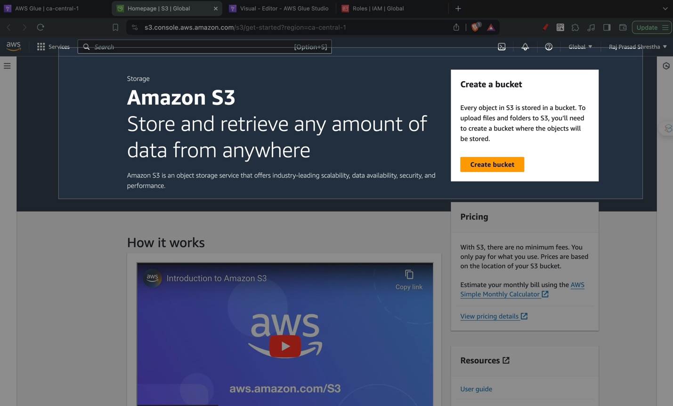

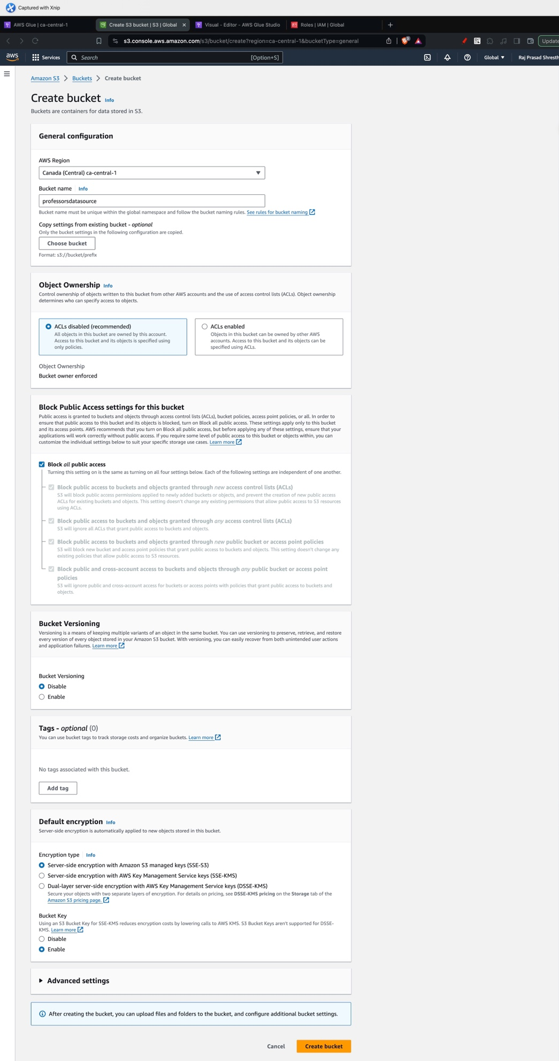

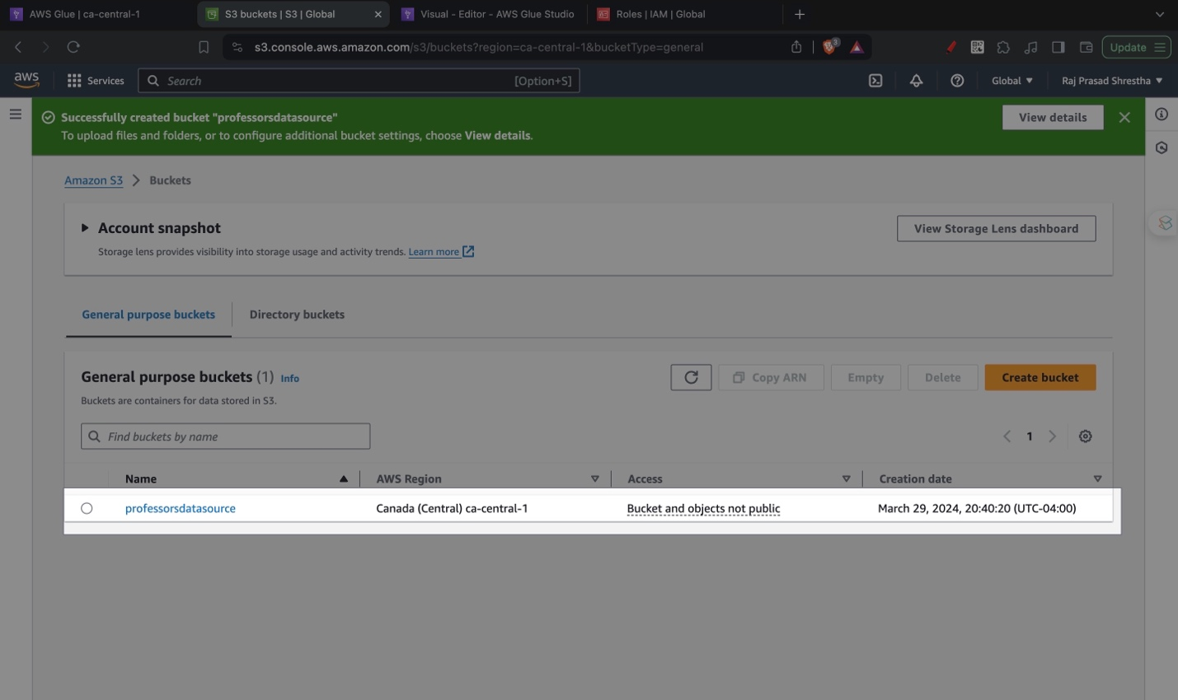

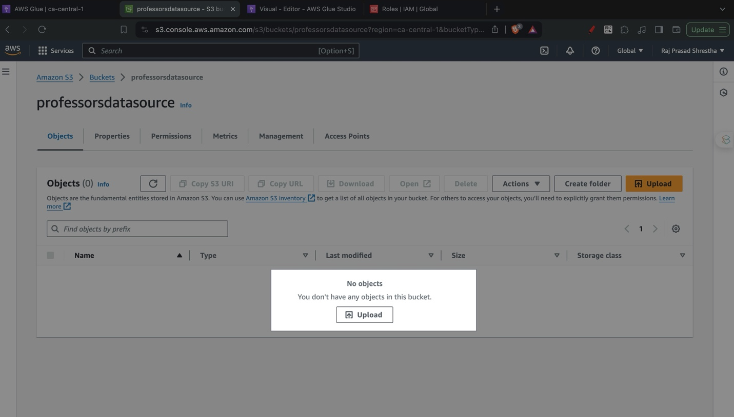

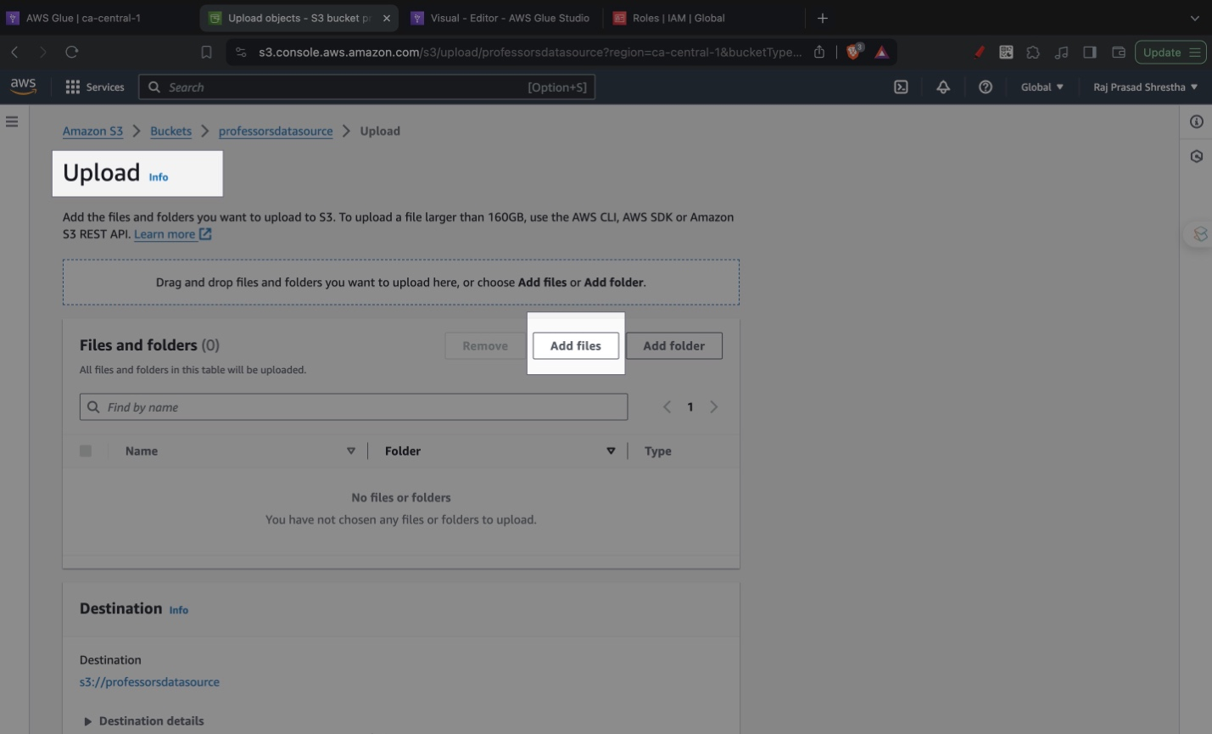

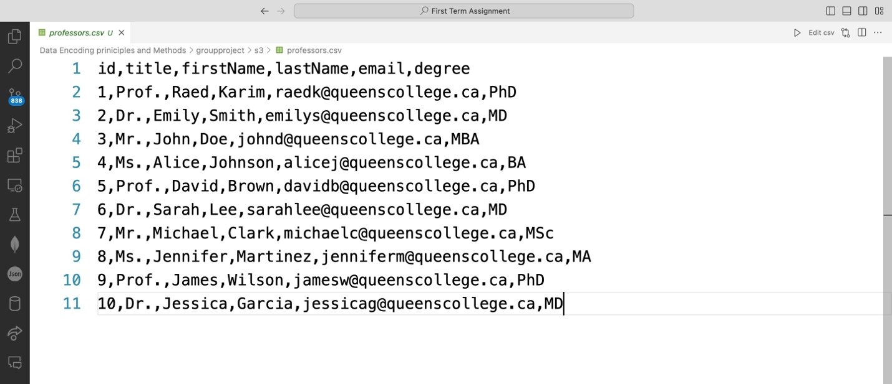

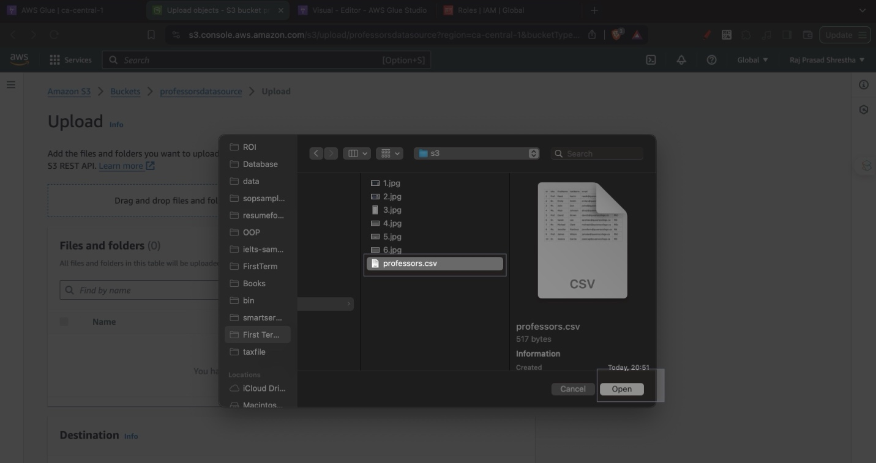

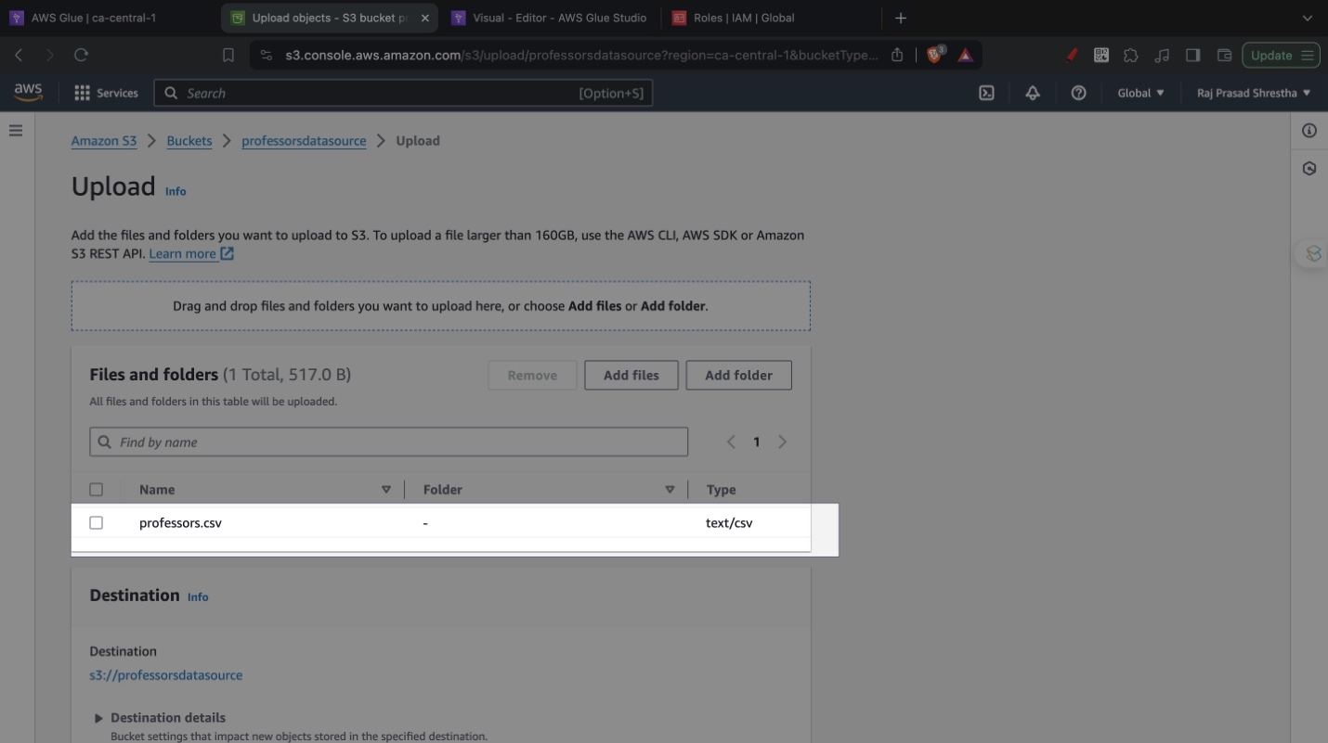

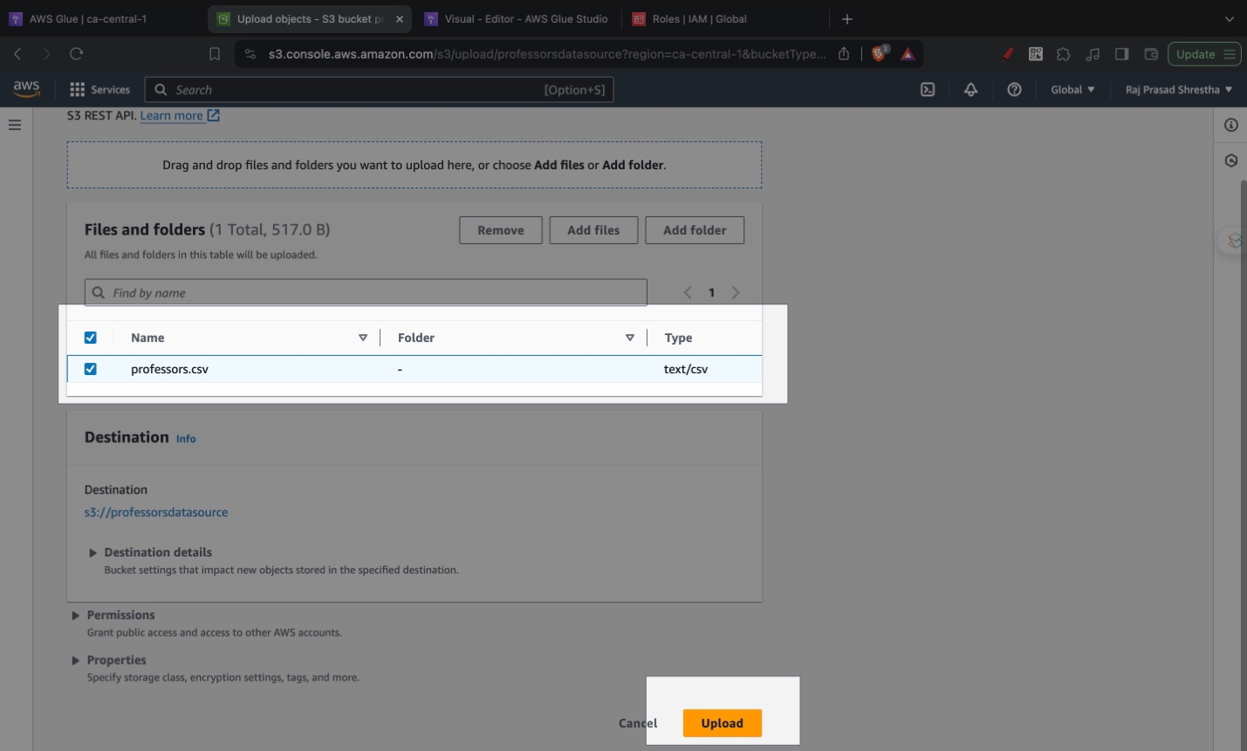

# Creating AWS Glue Data Catalog

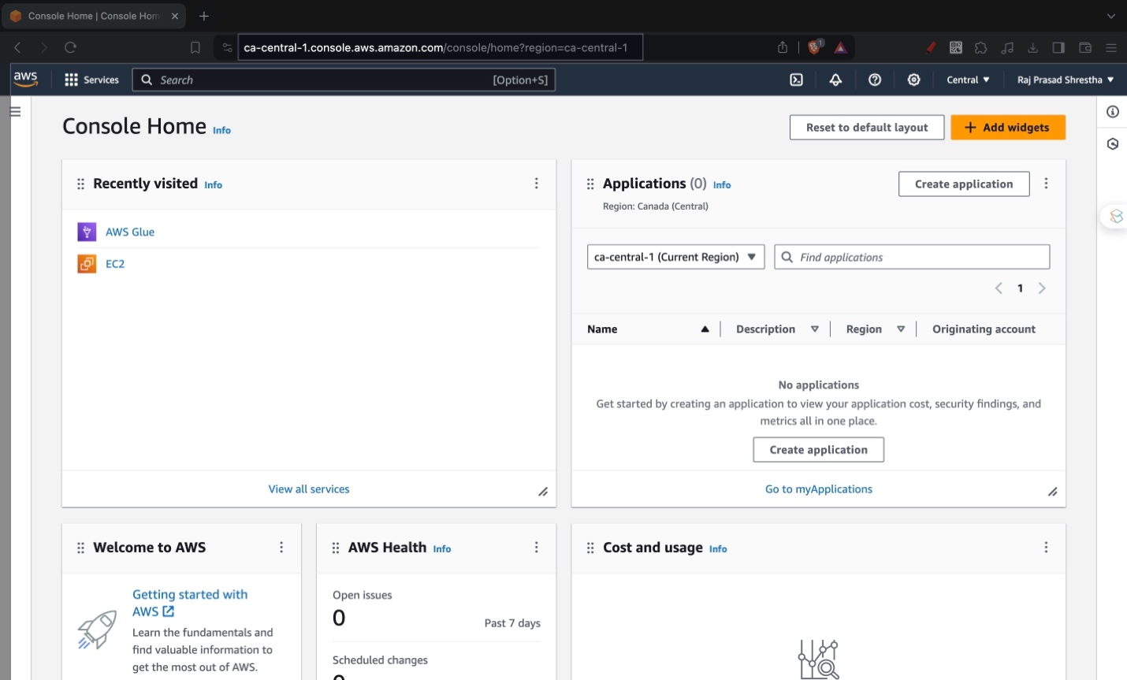

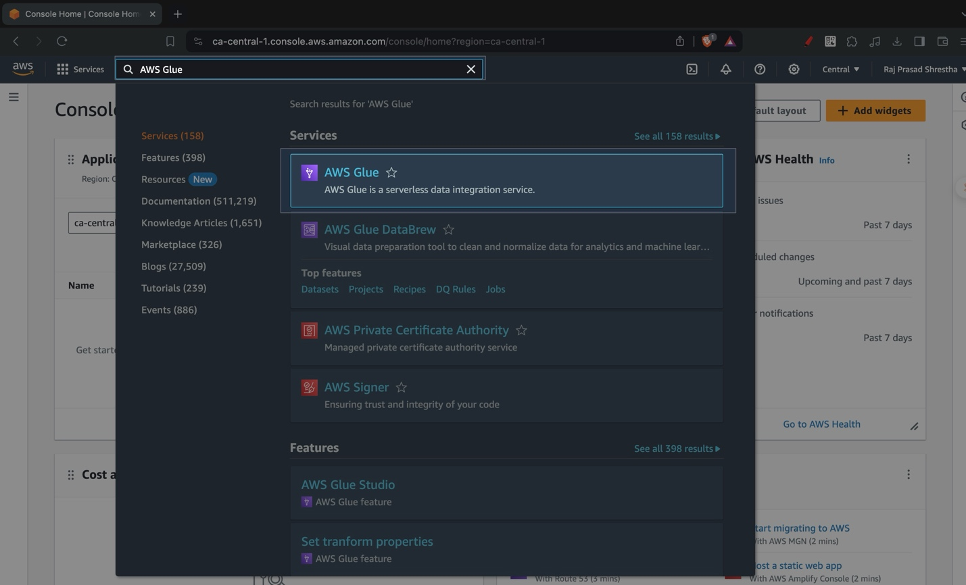

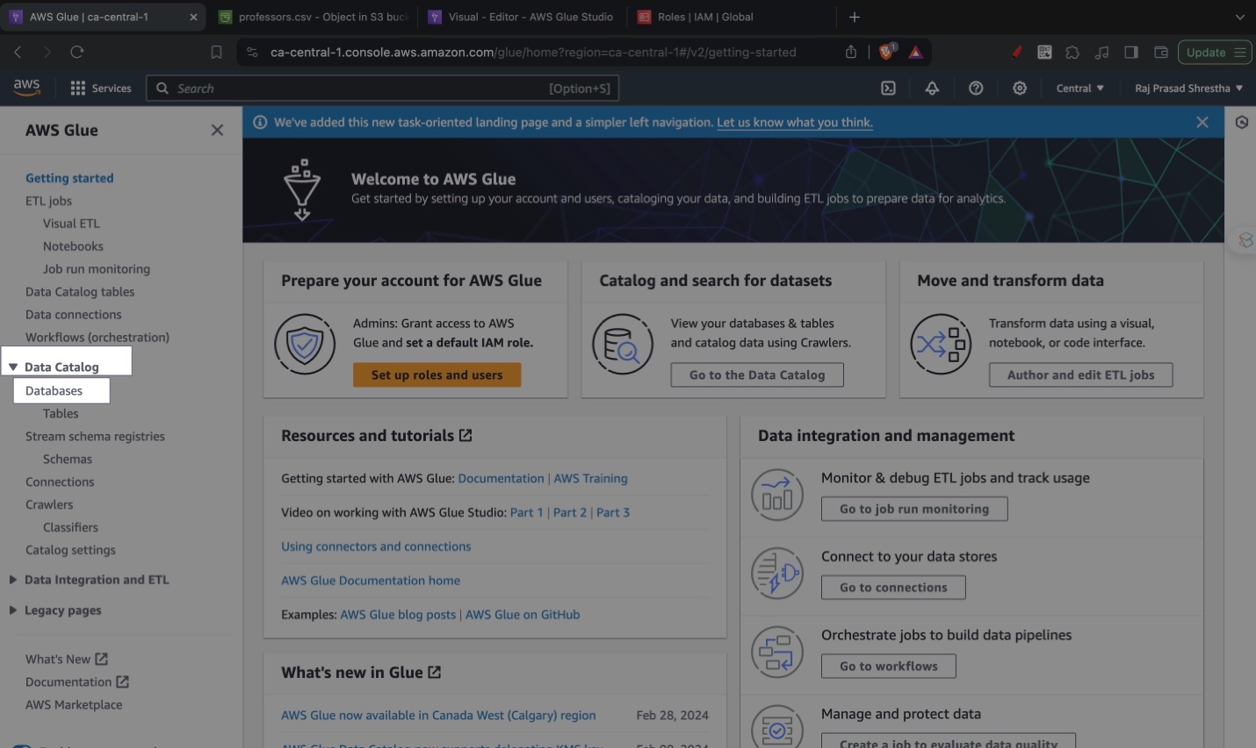

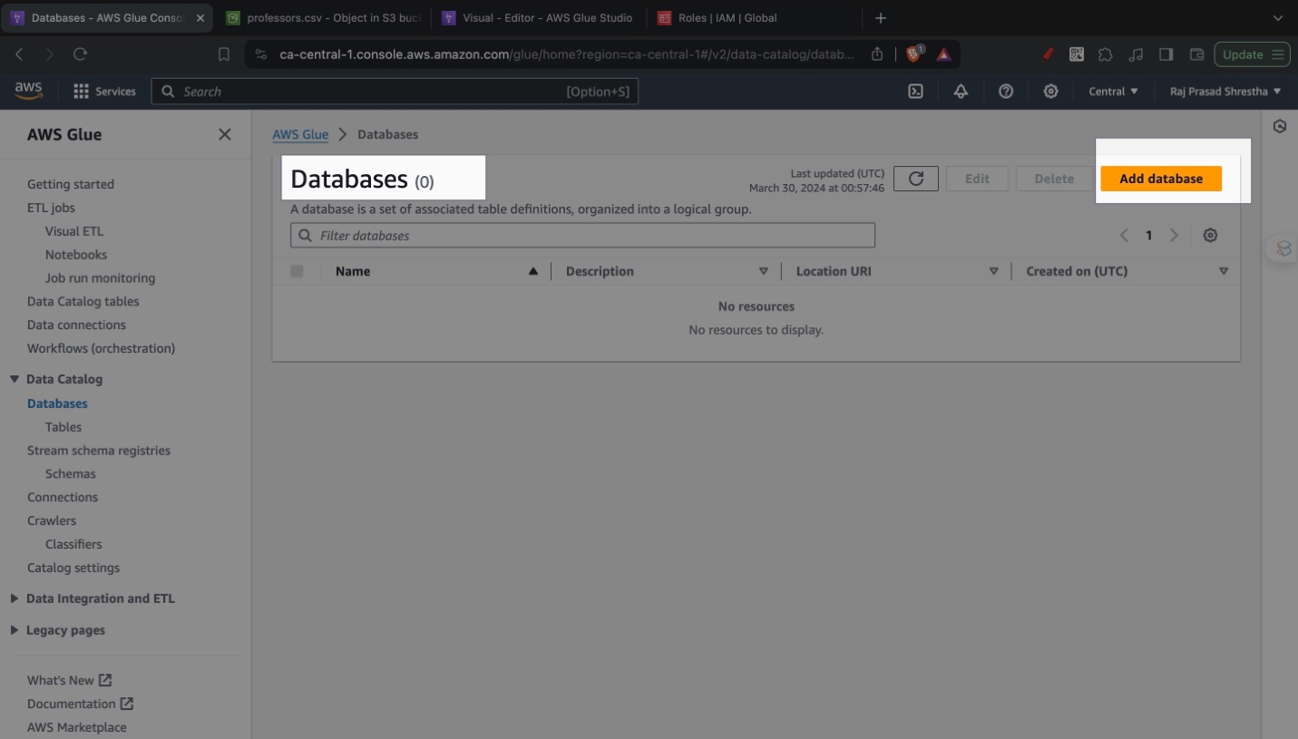

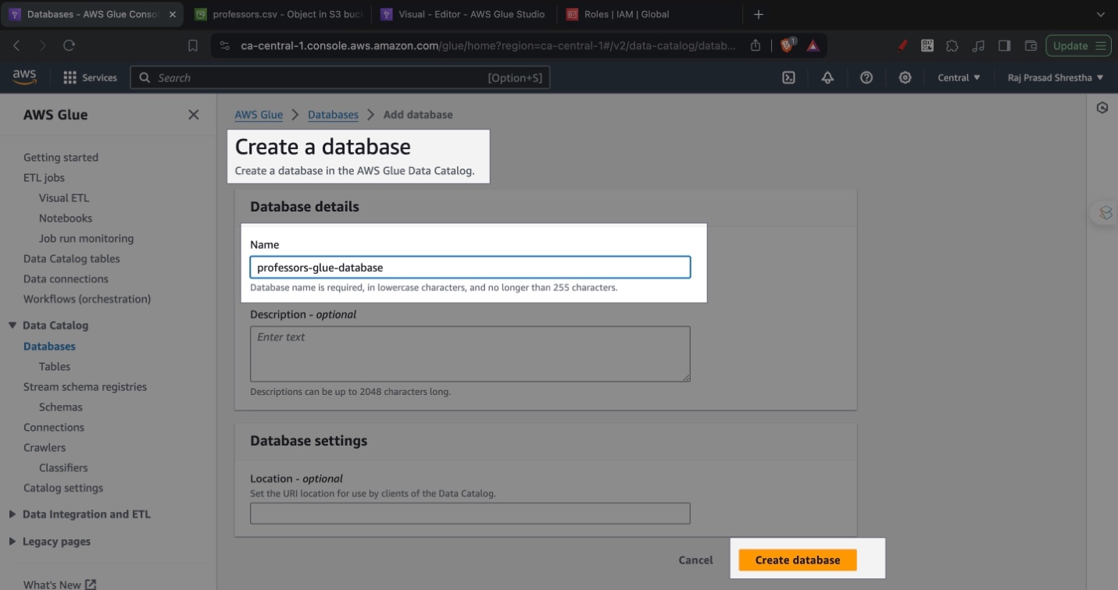

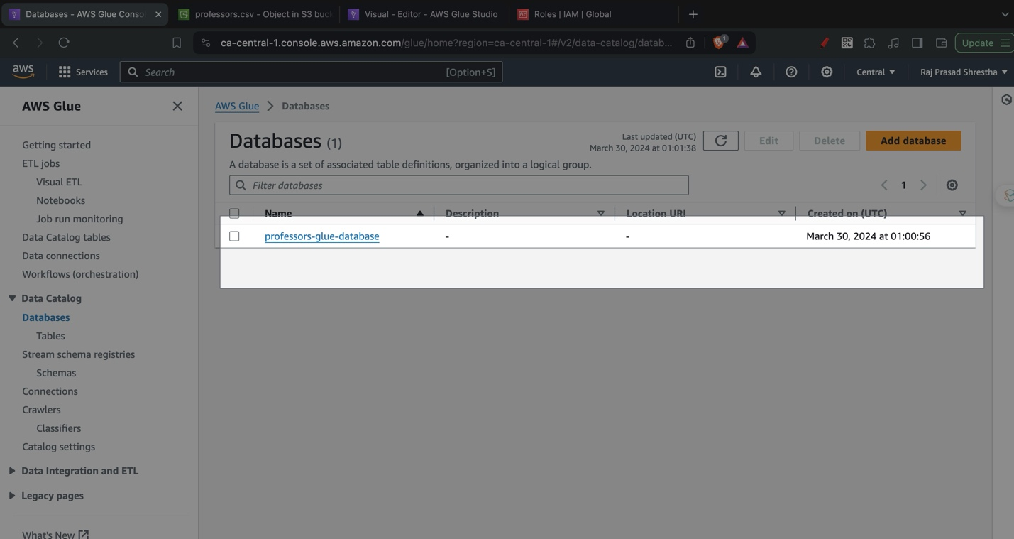

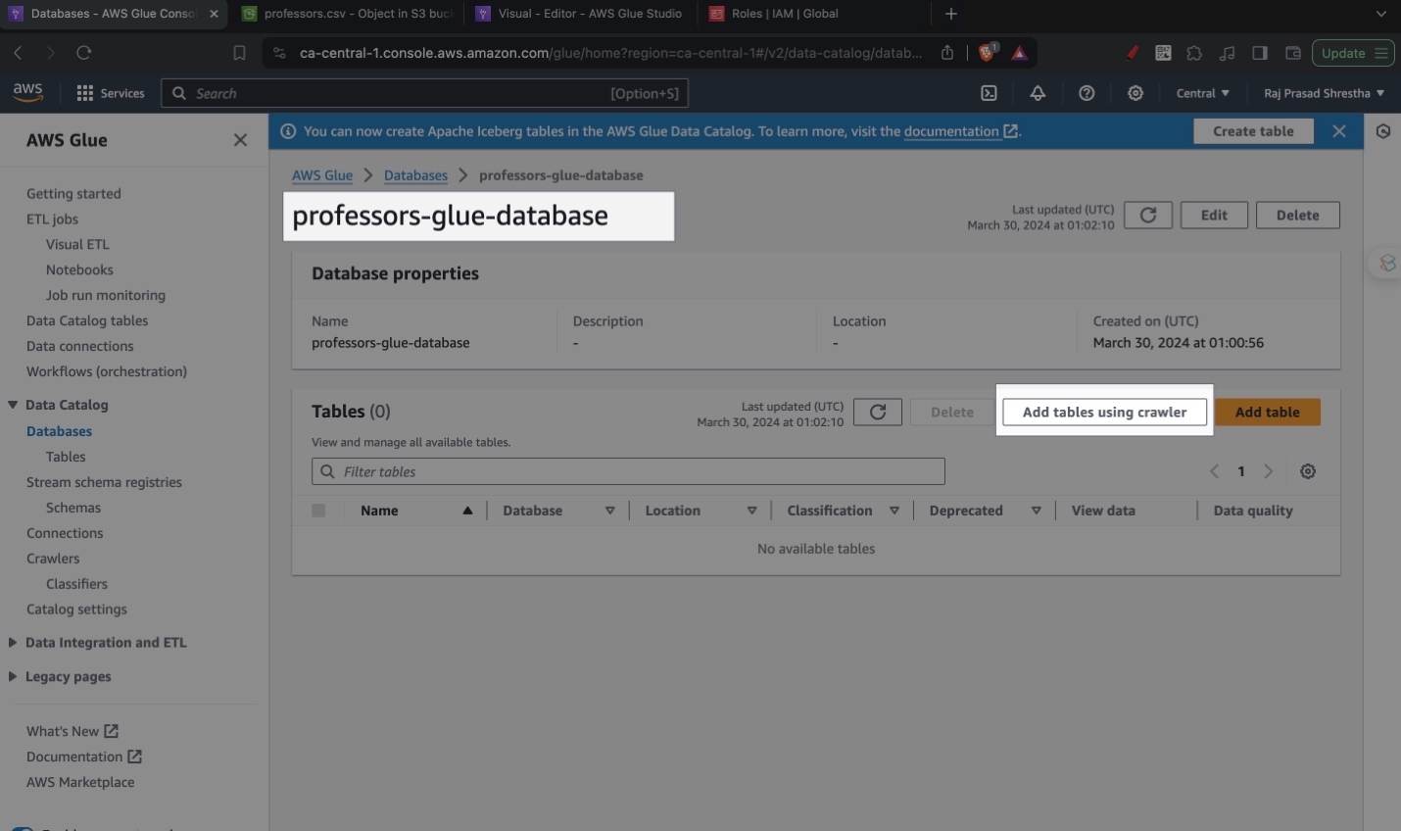

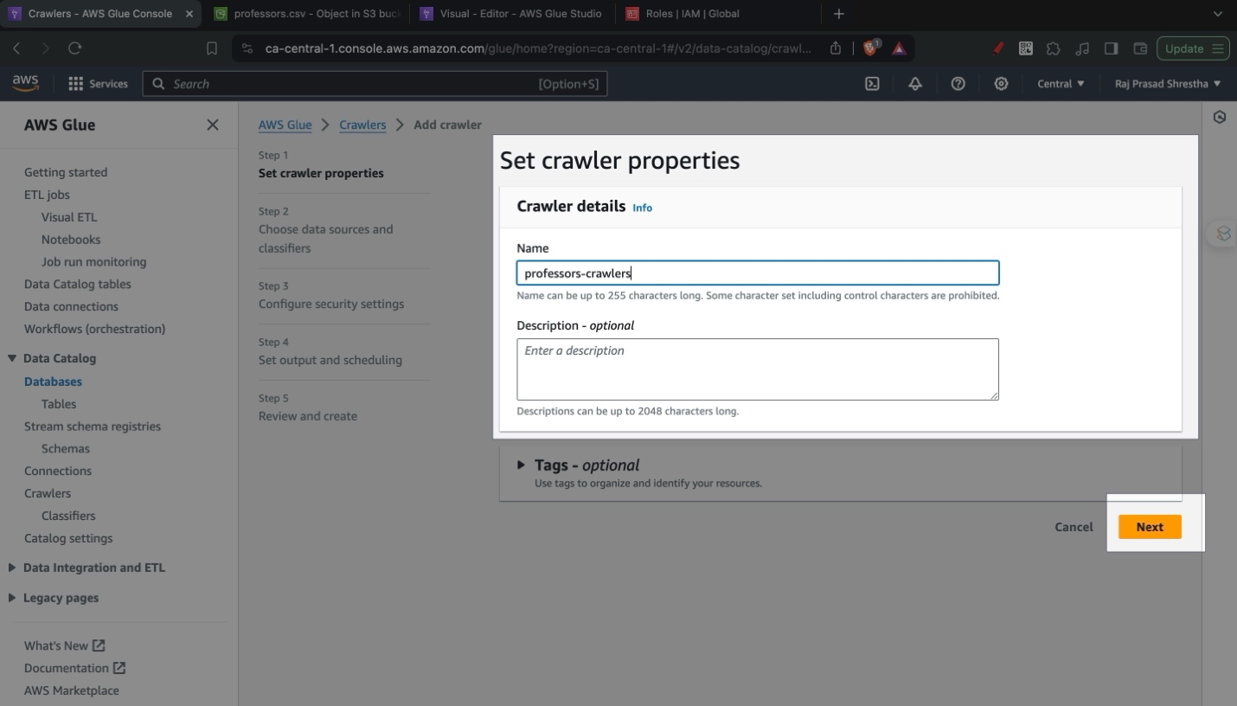



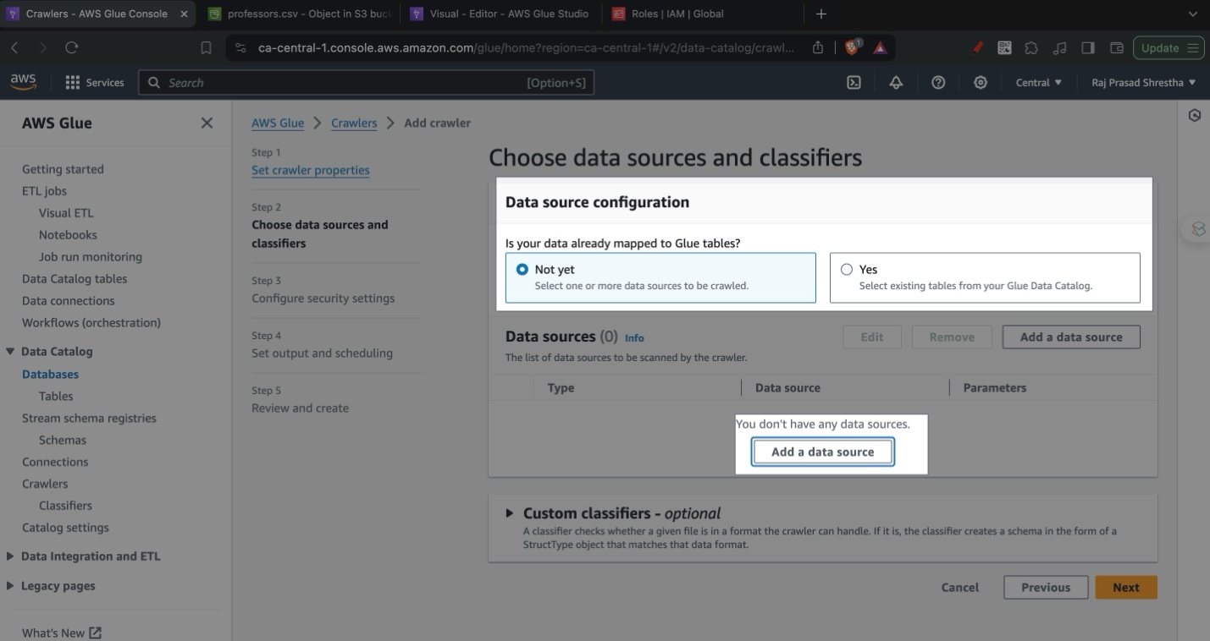

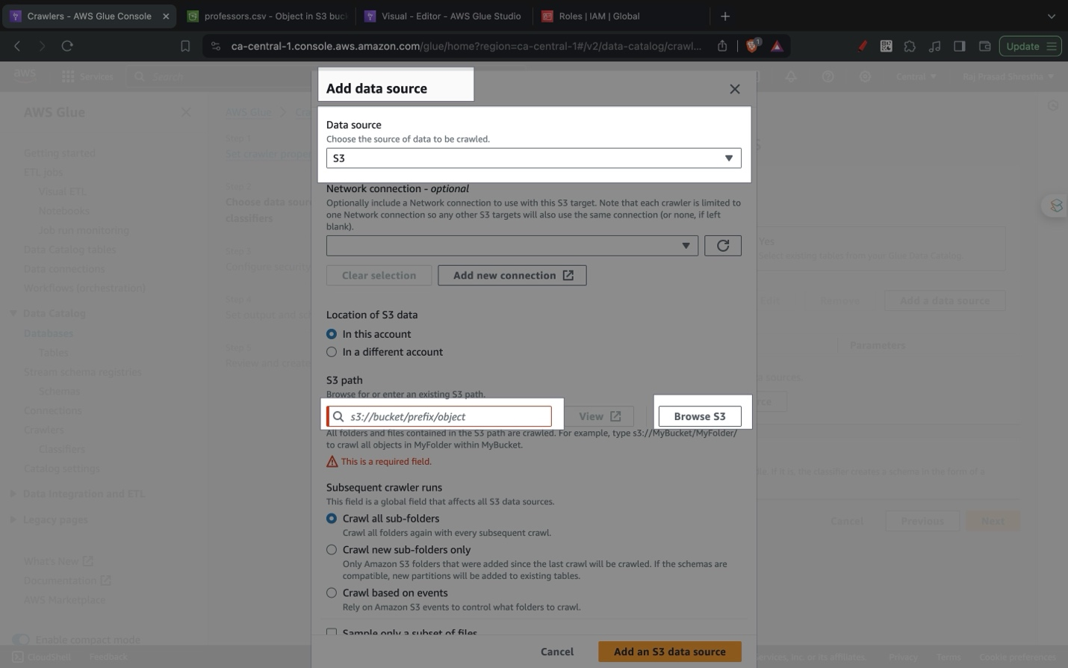

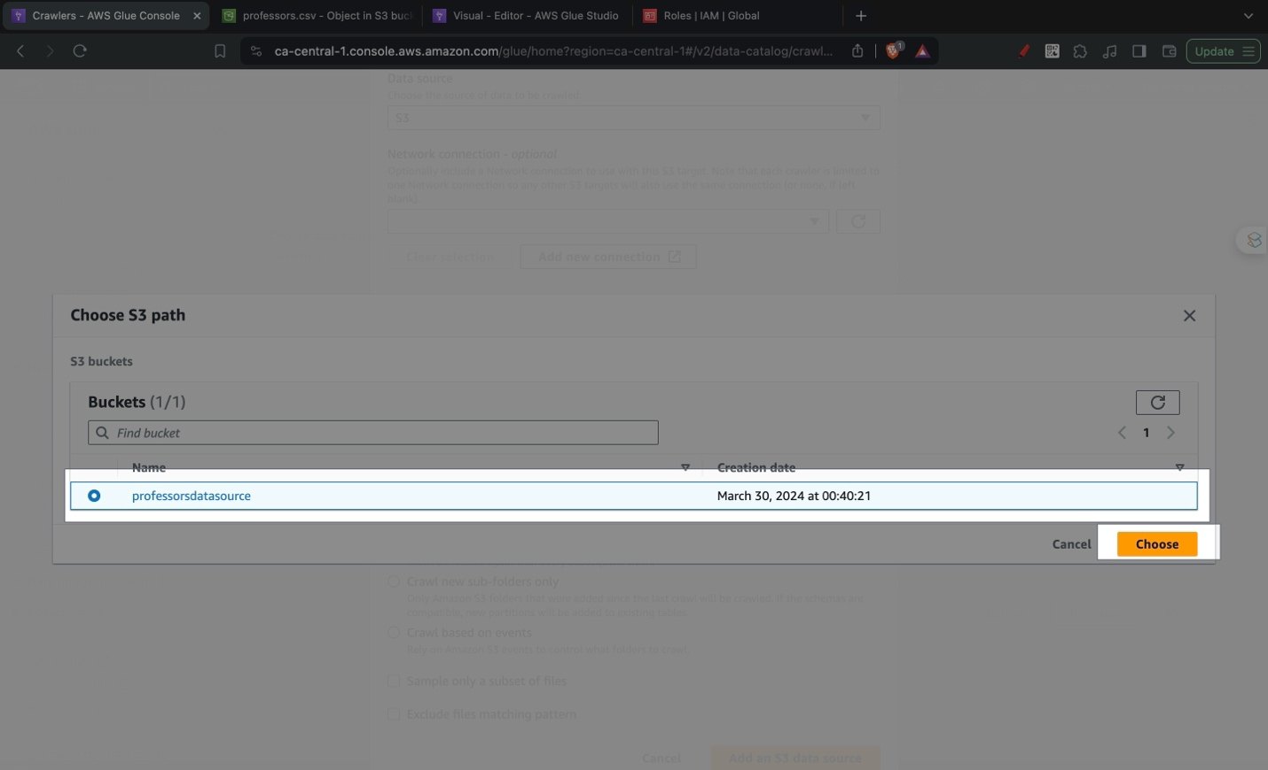

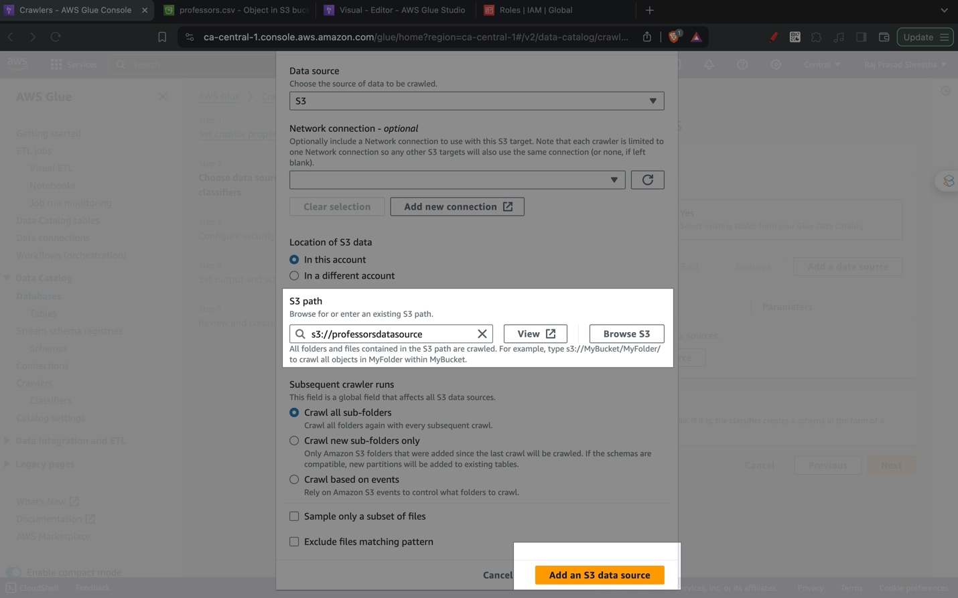

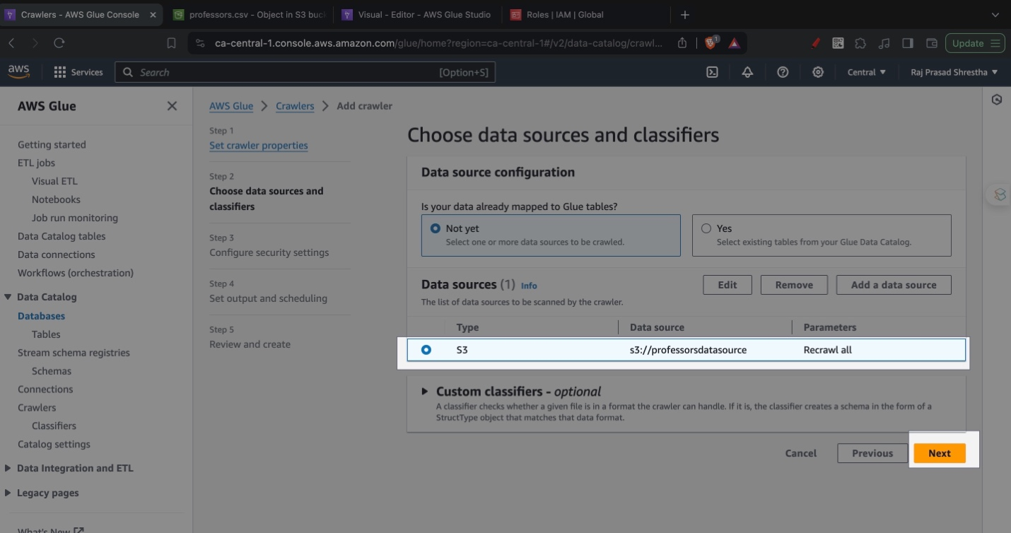

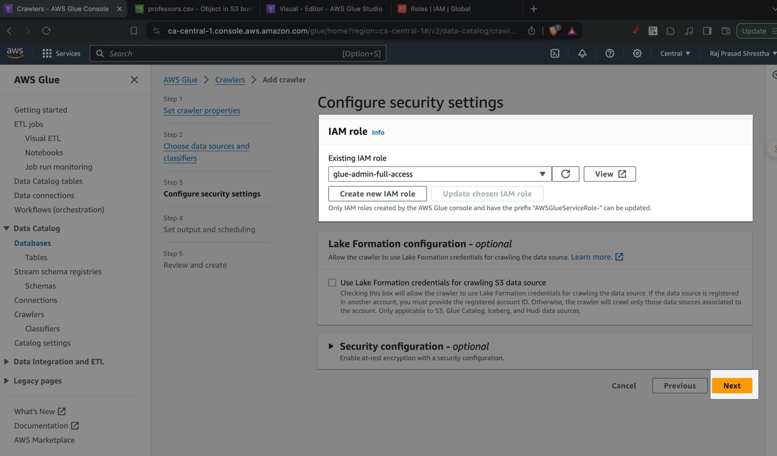

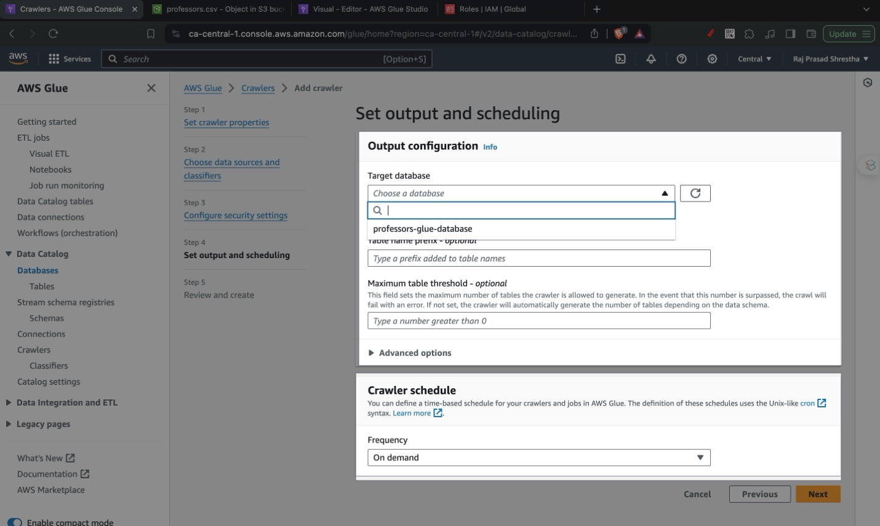

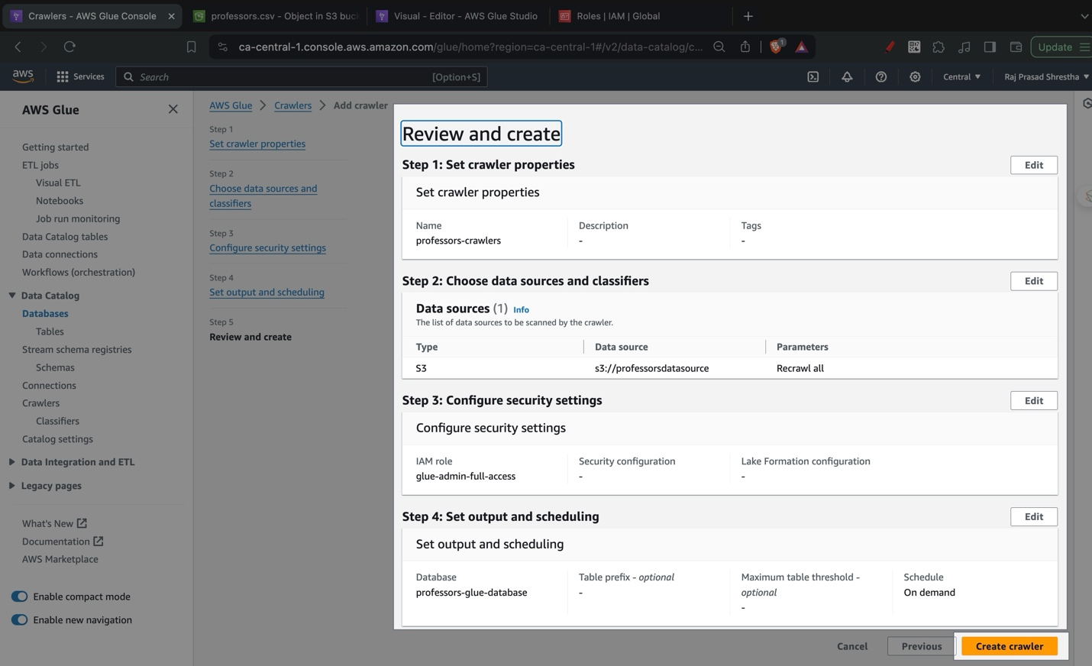

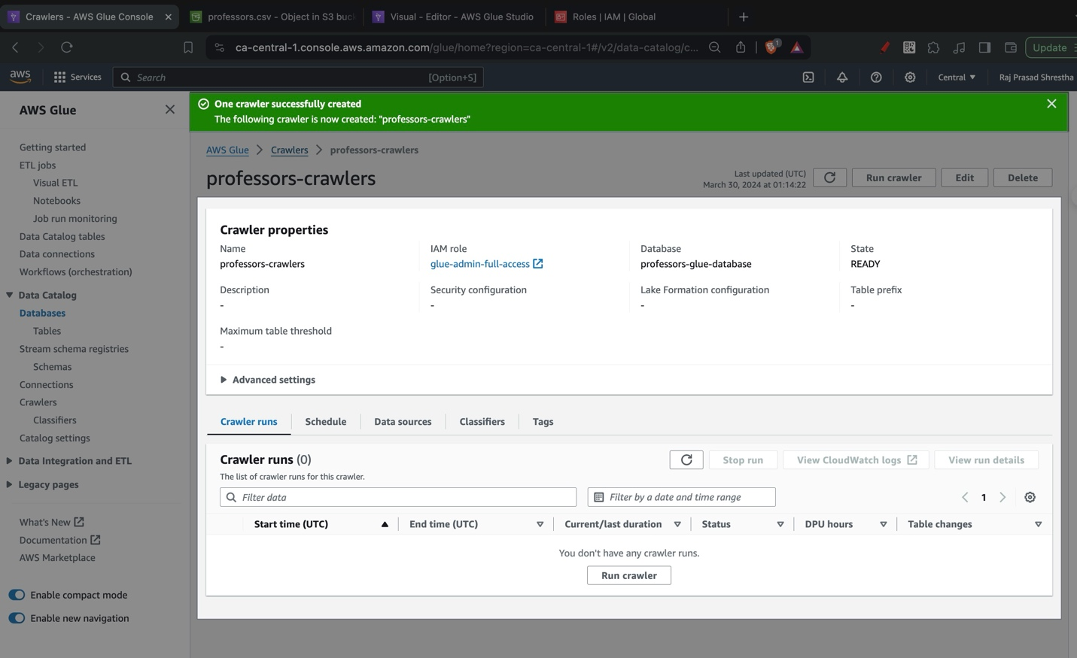

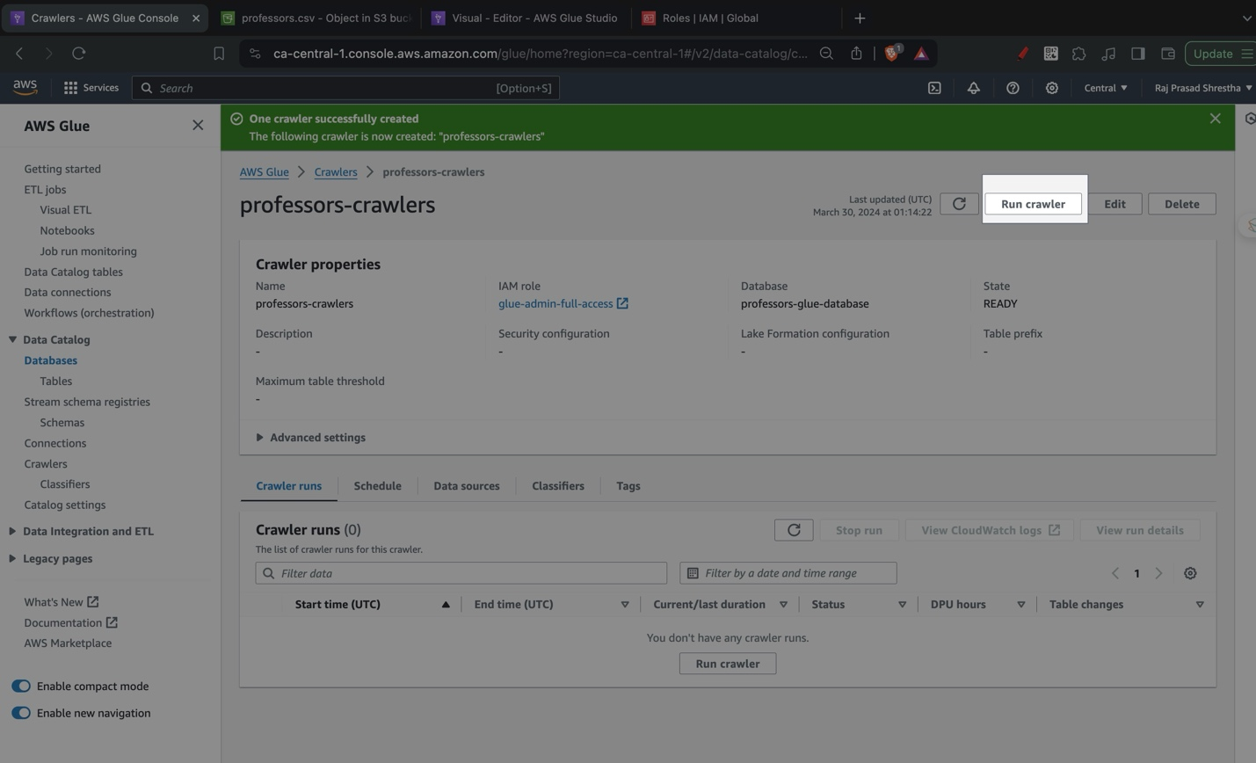

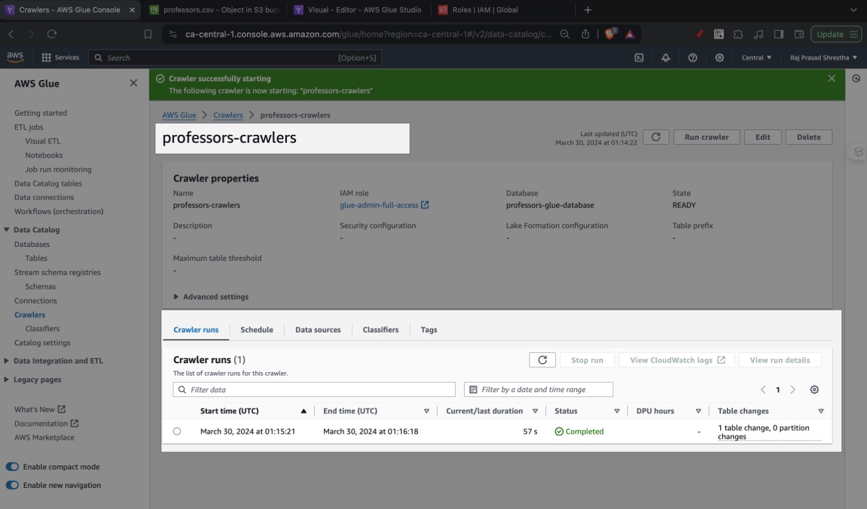

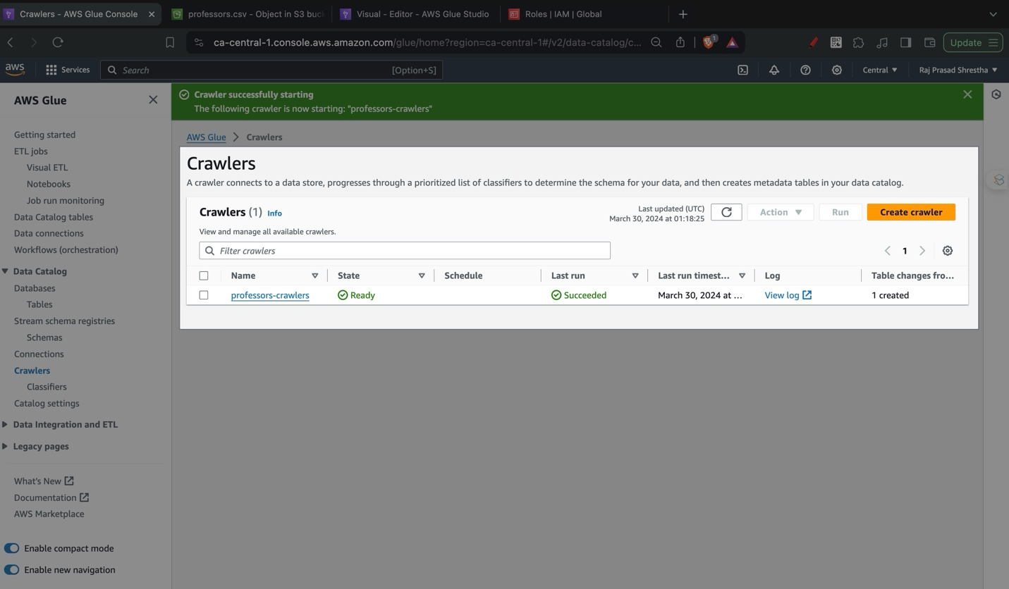

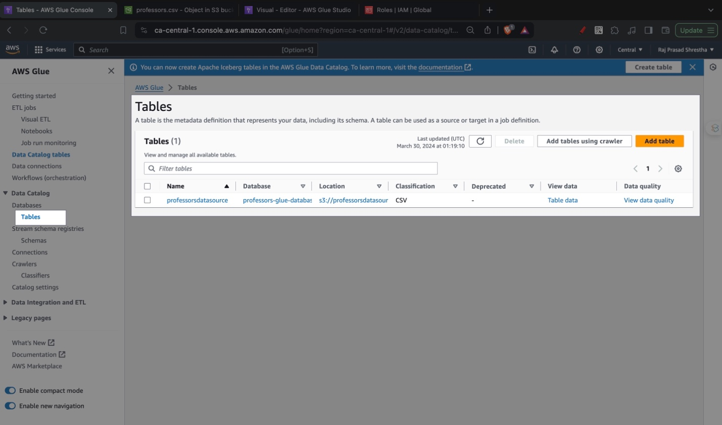

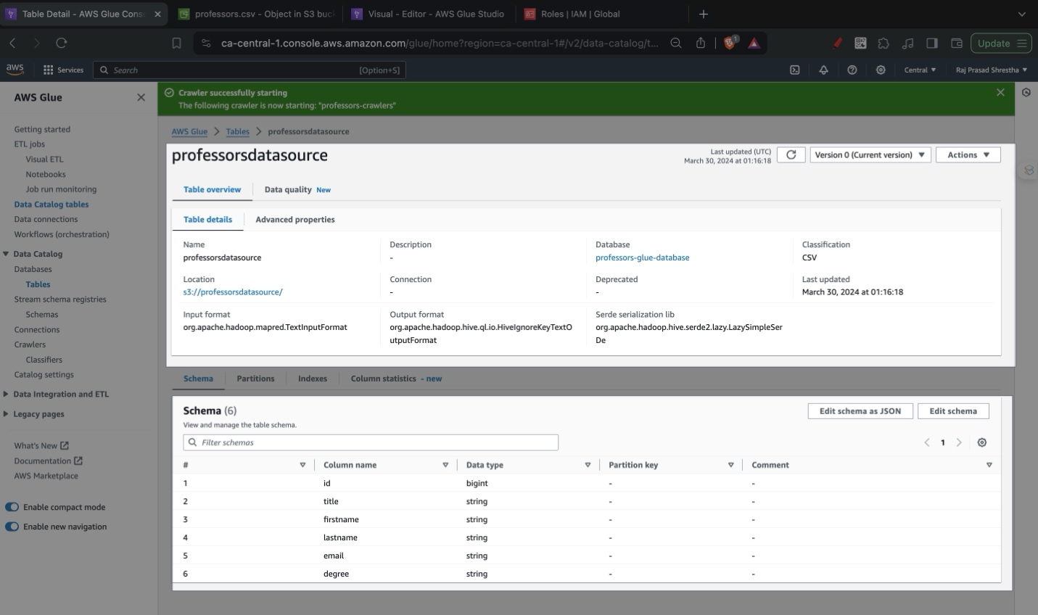

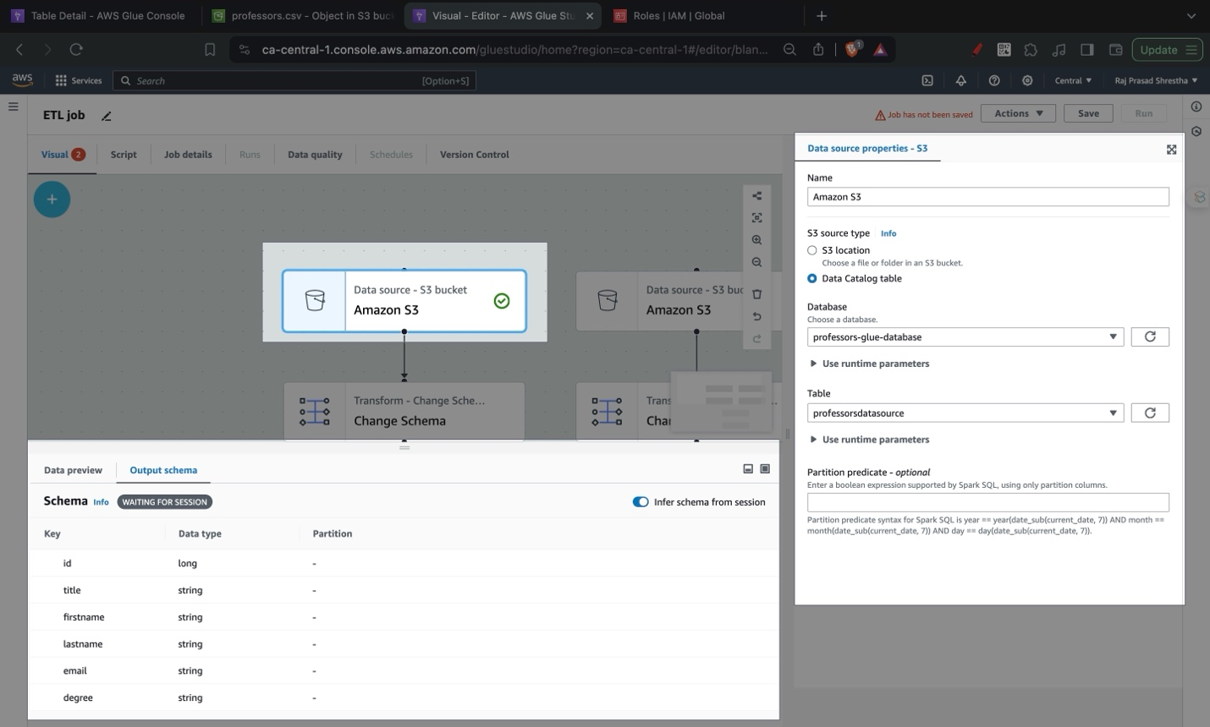

# Building Visual ETL Jobs

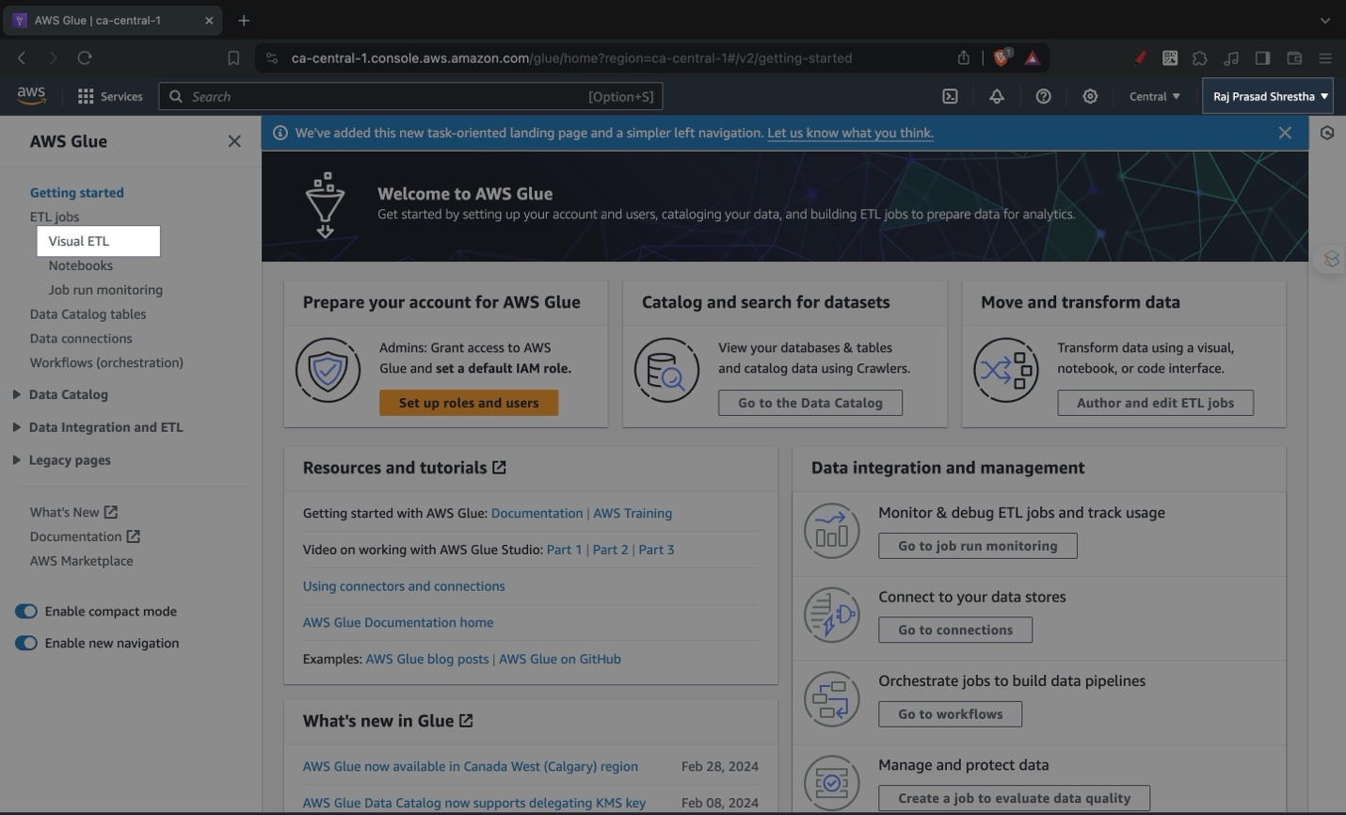

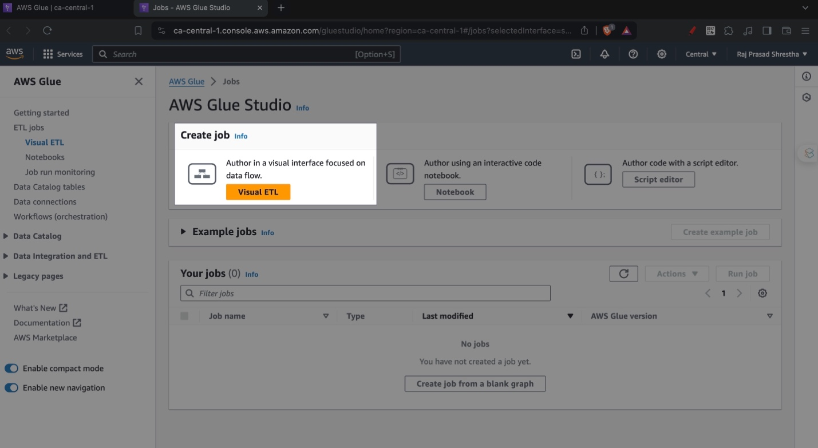

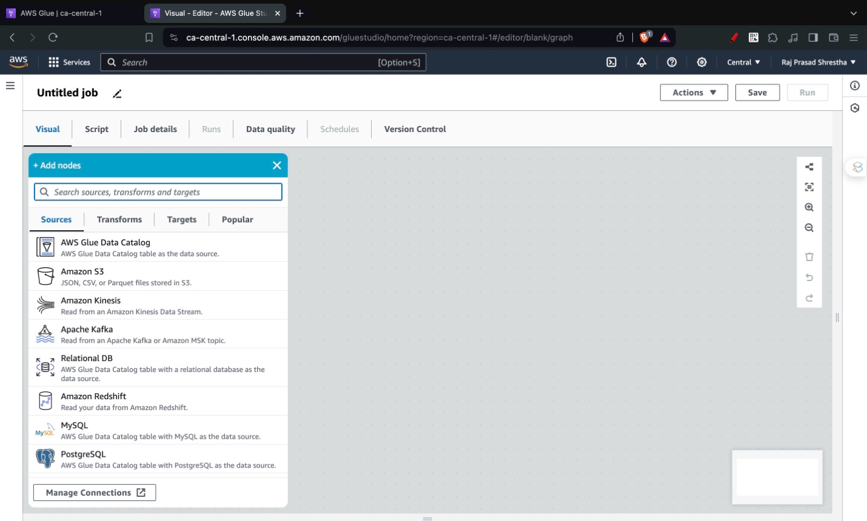



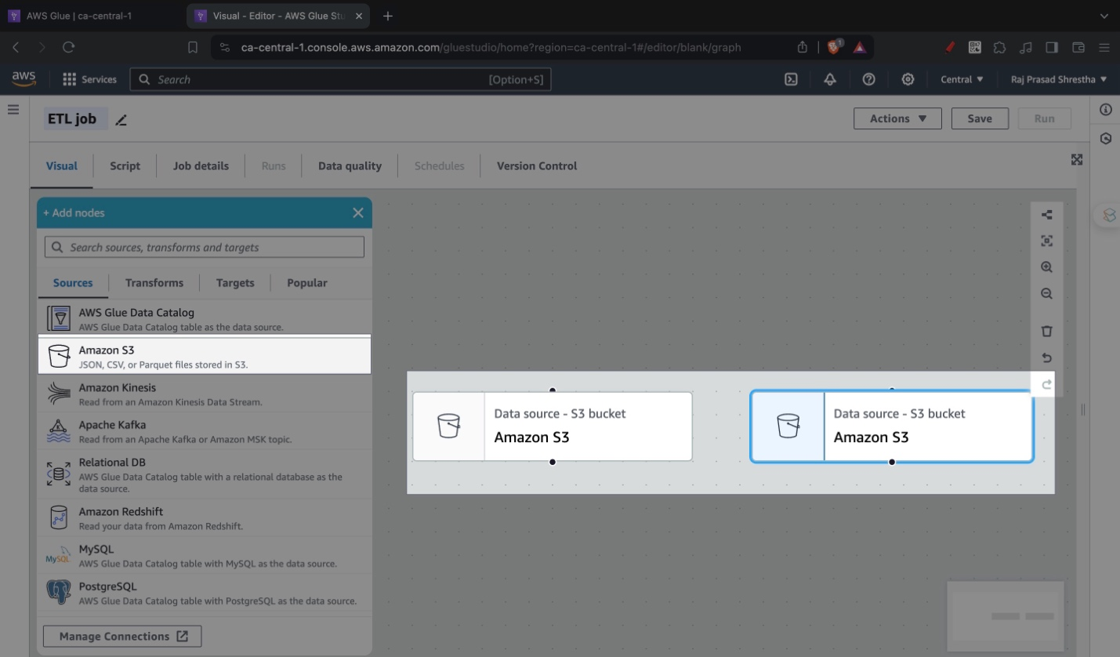

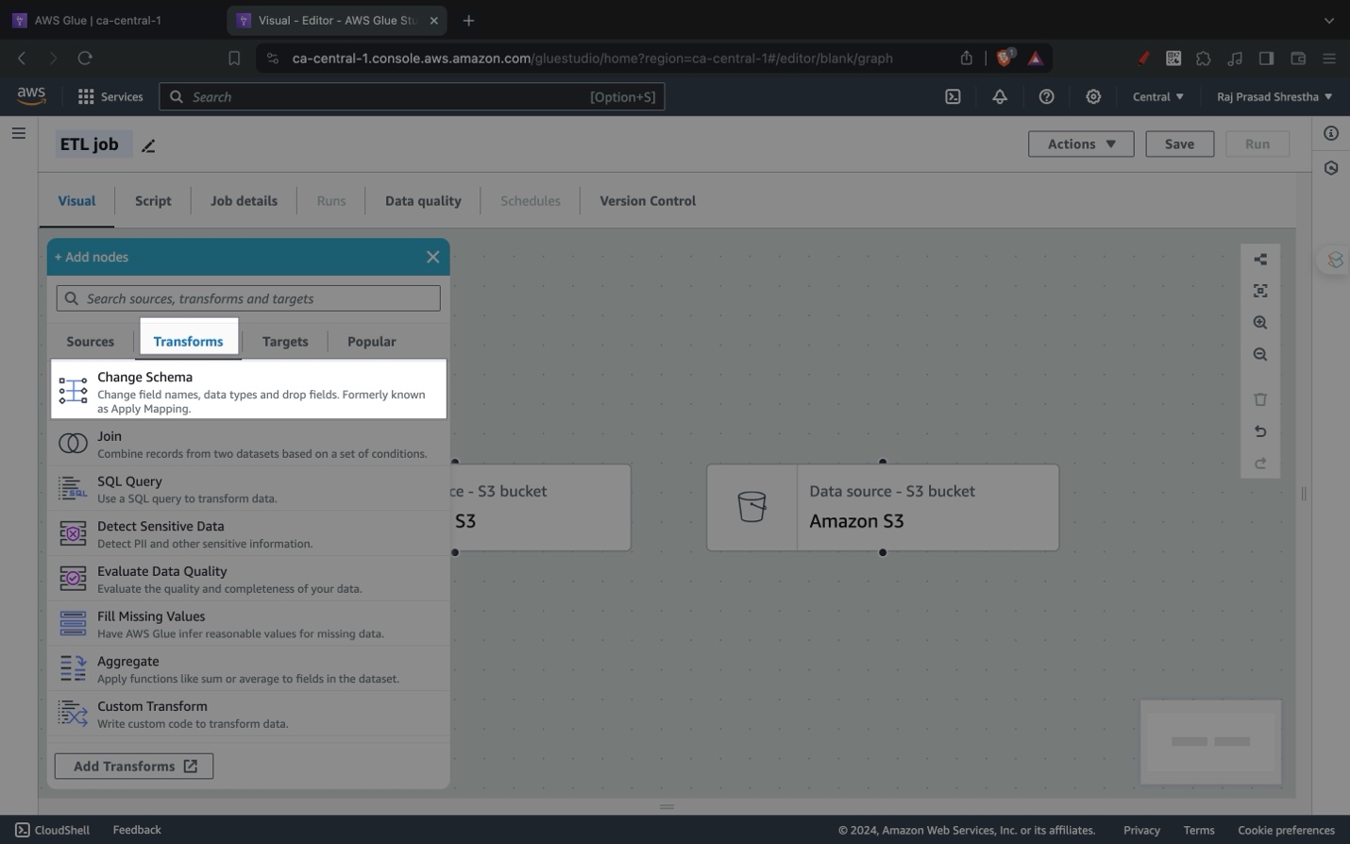

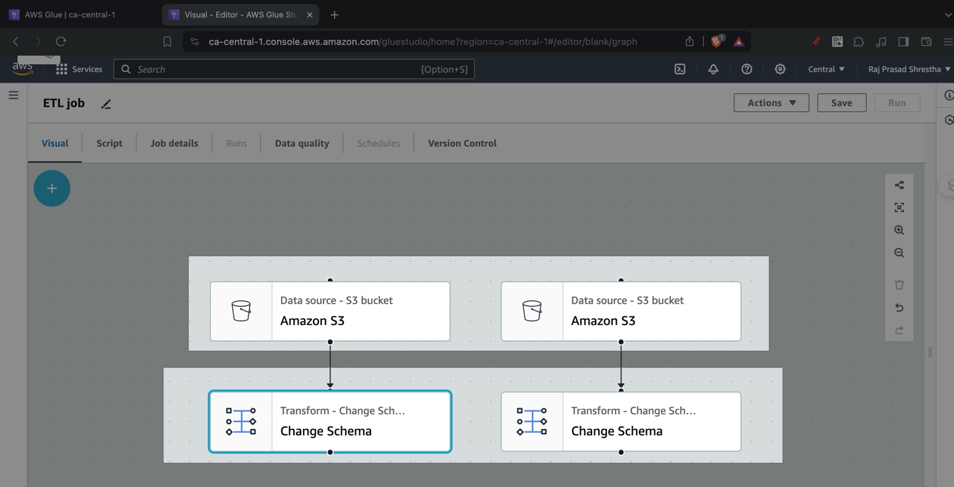

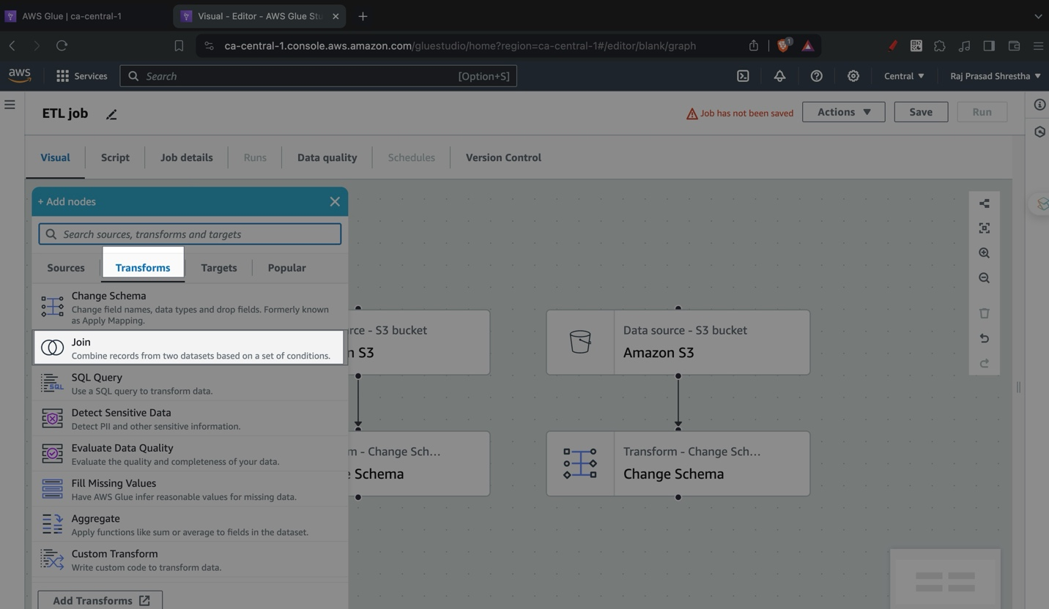

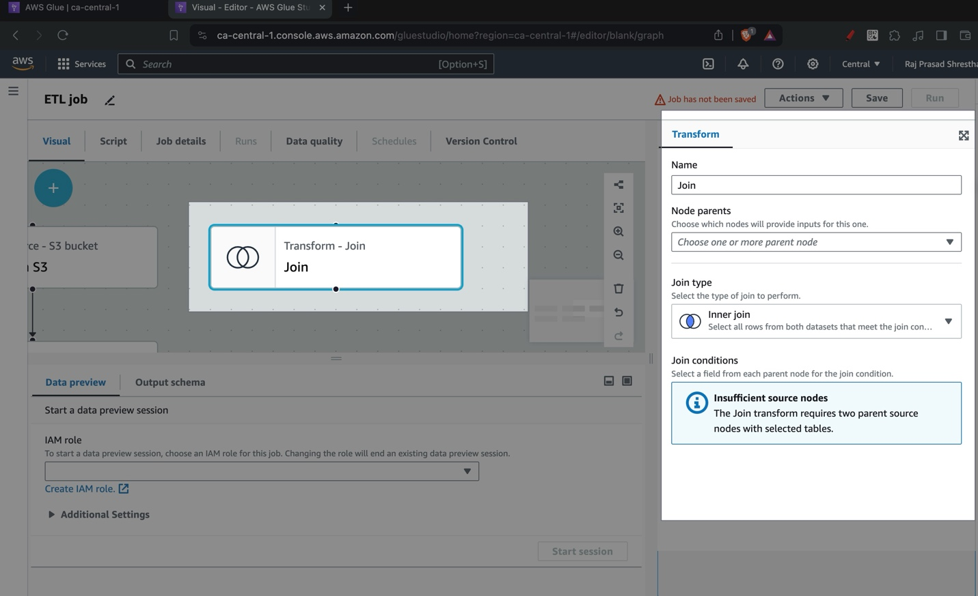

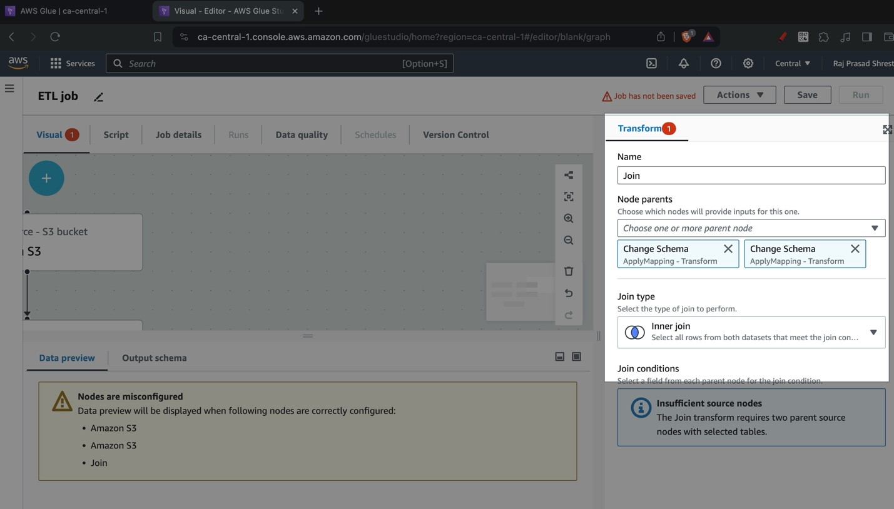

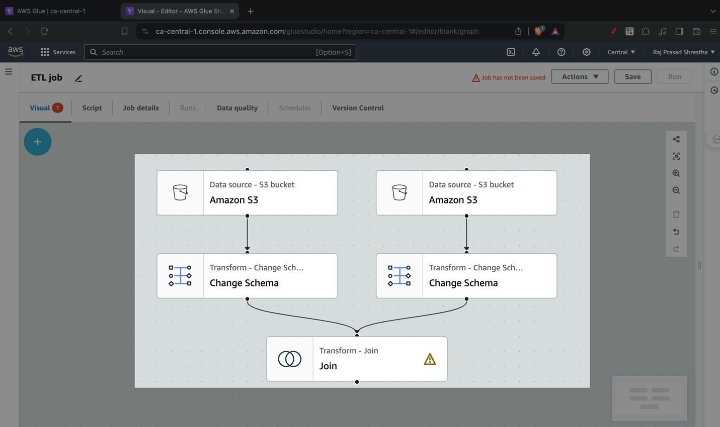

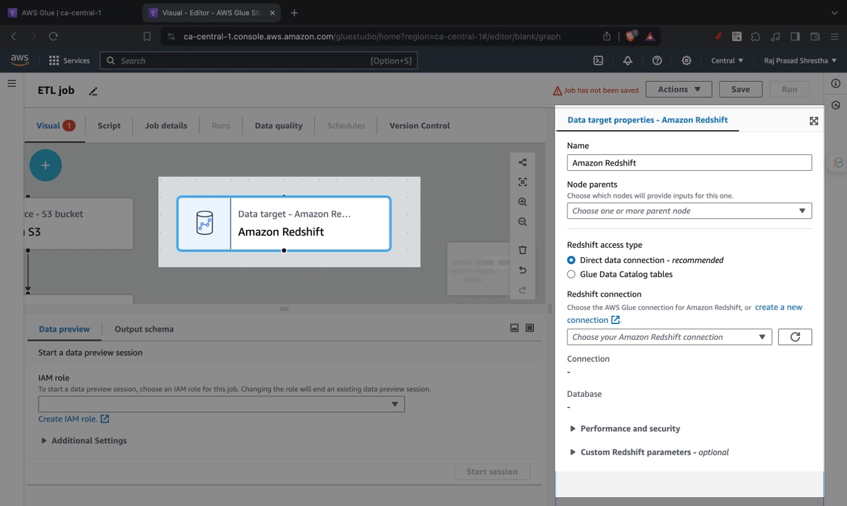

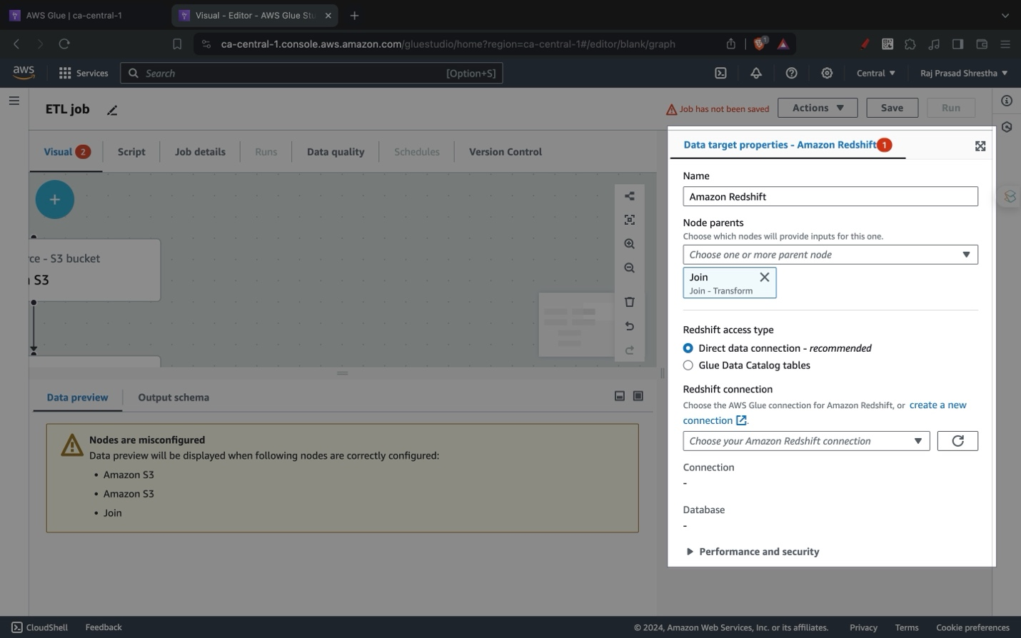

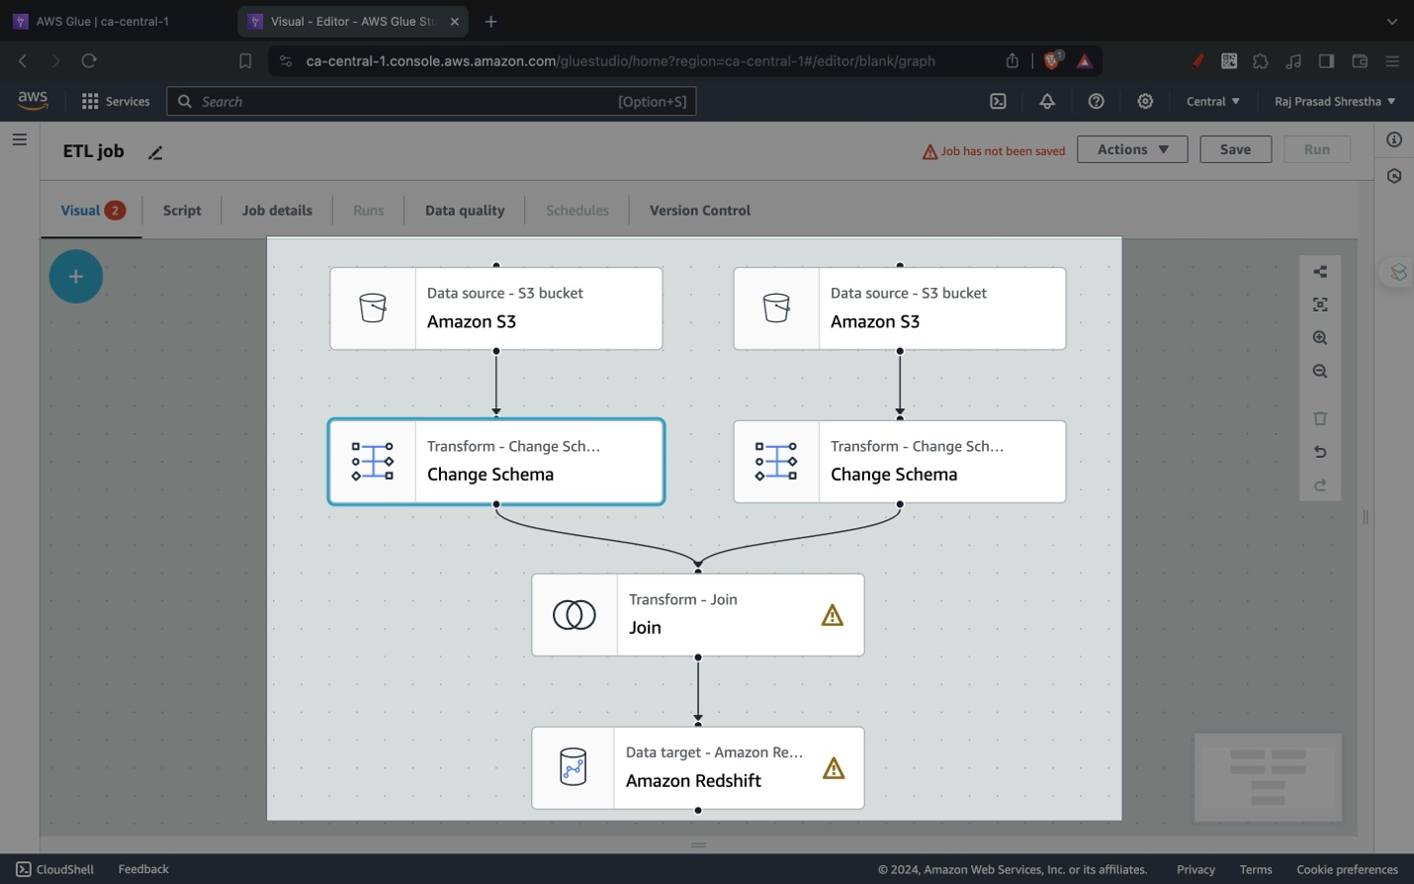

# Amazon Redshift Setup

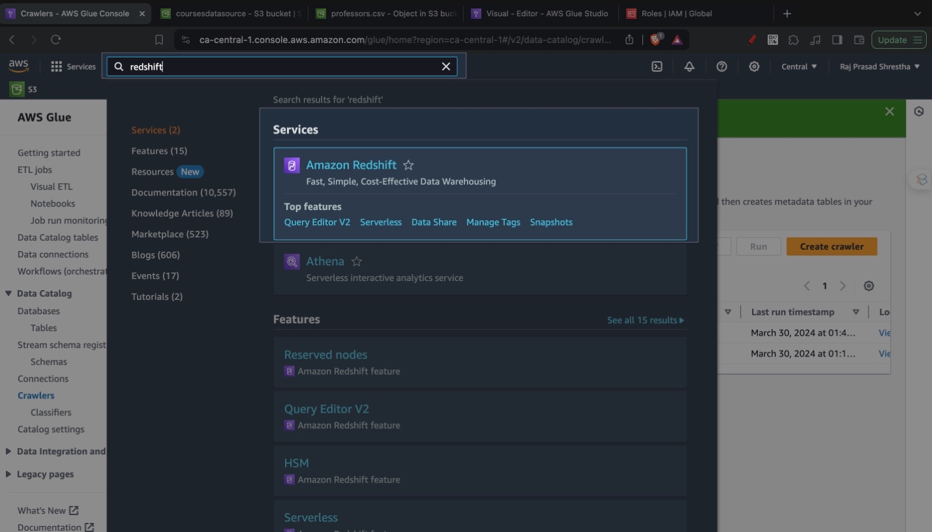

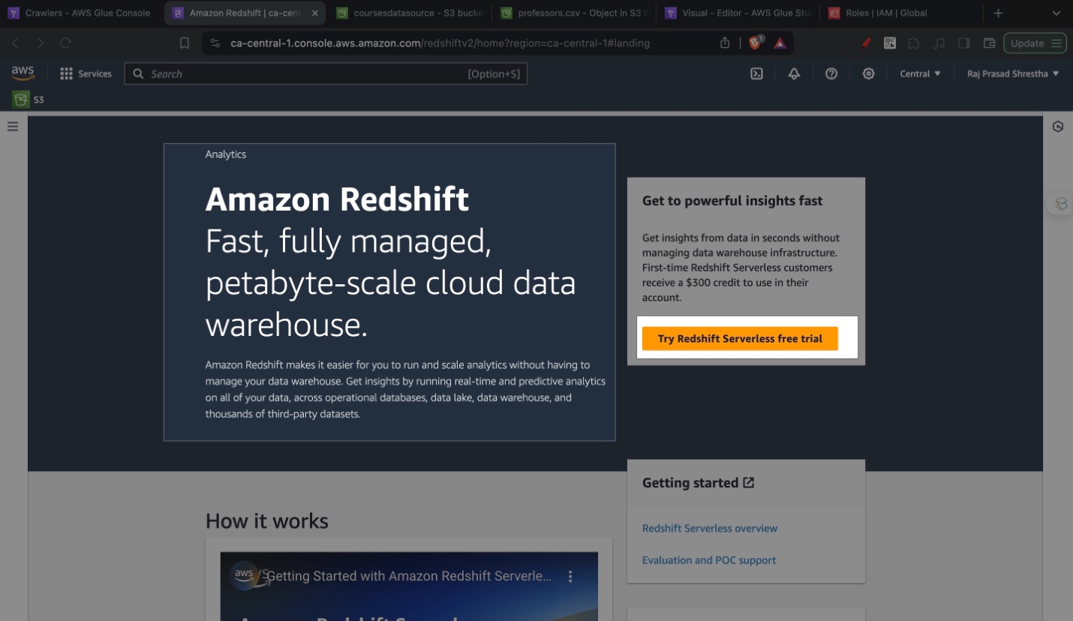

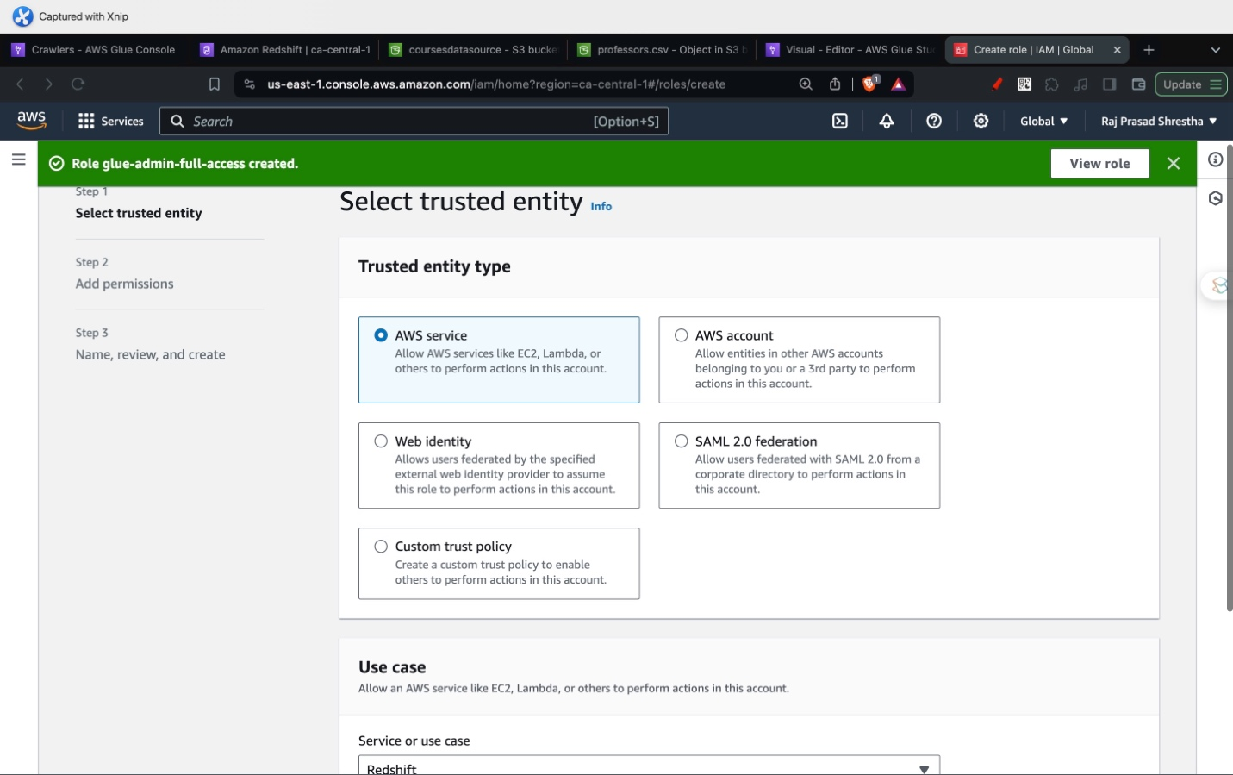

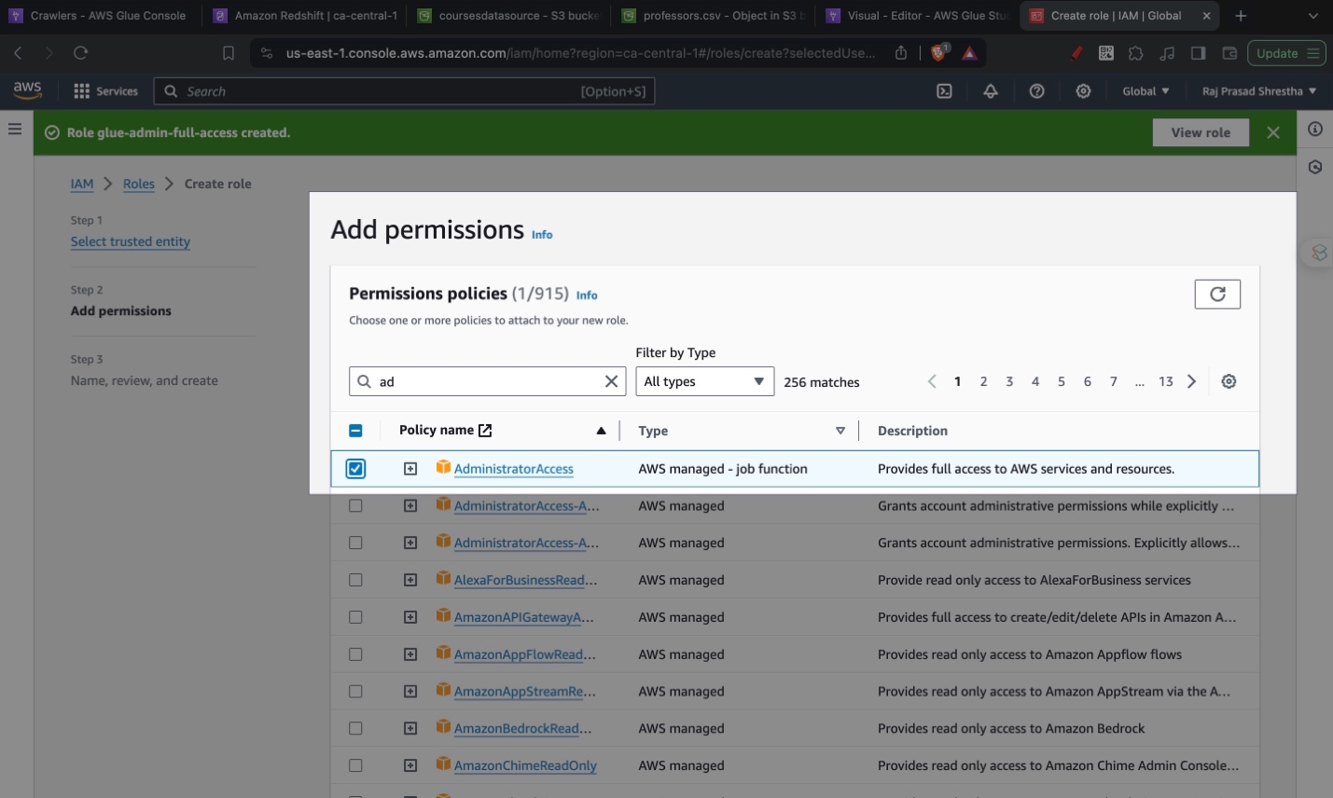

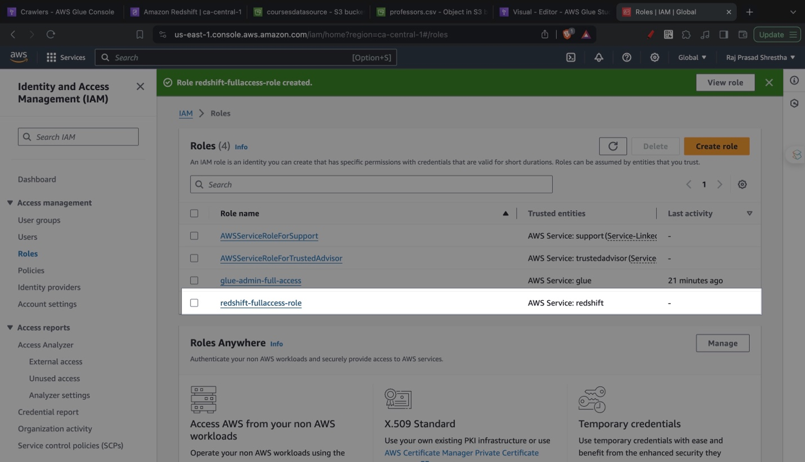

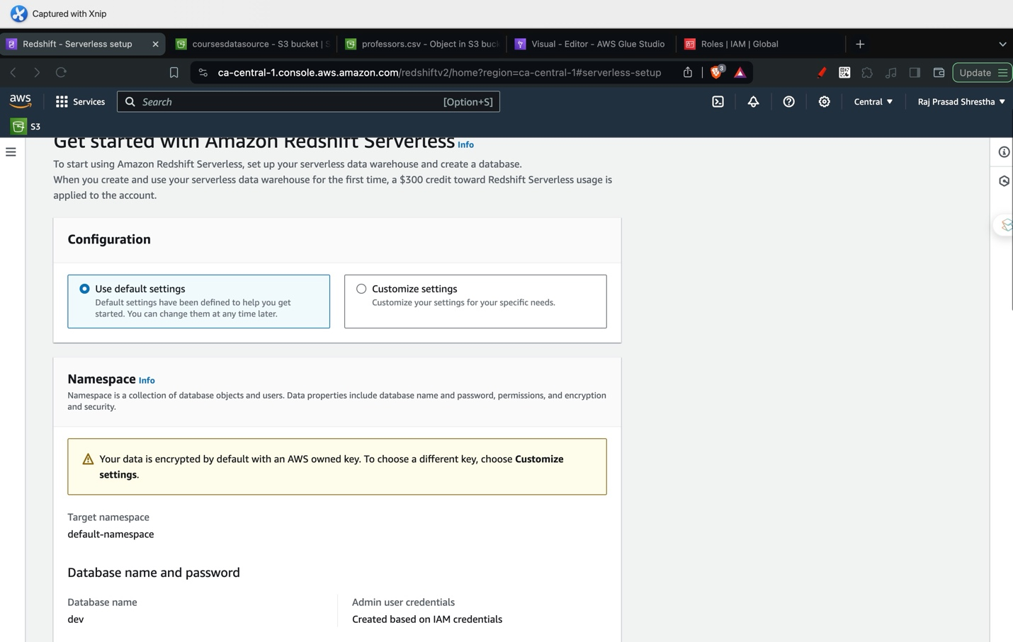

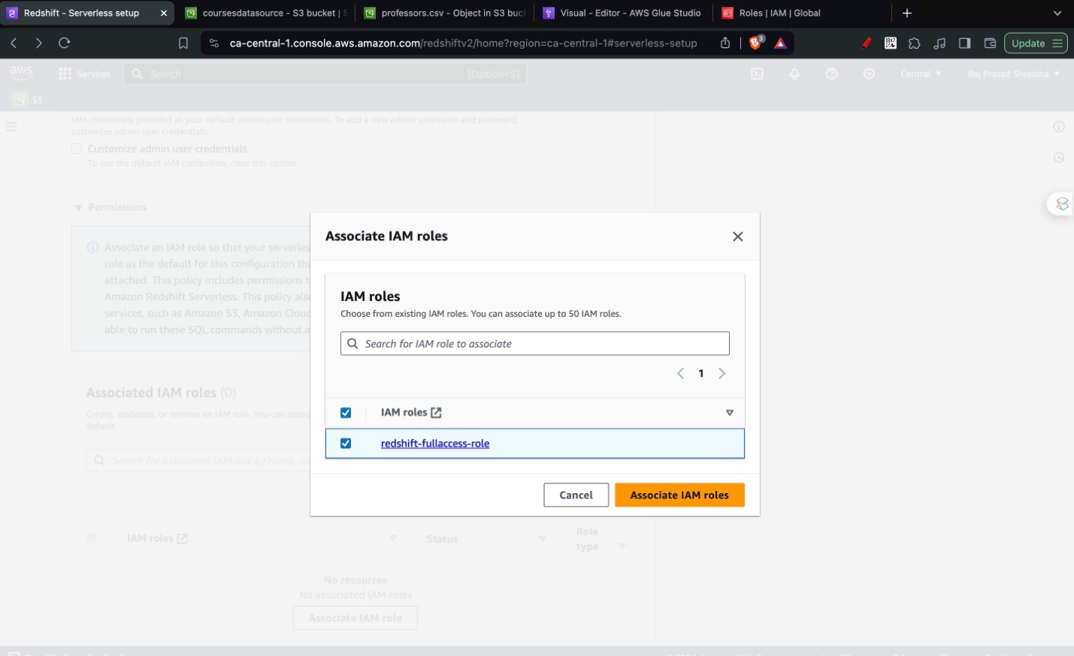

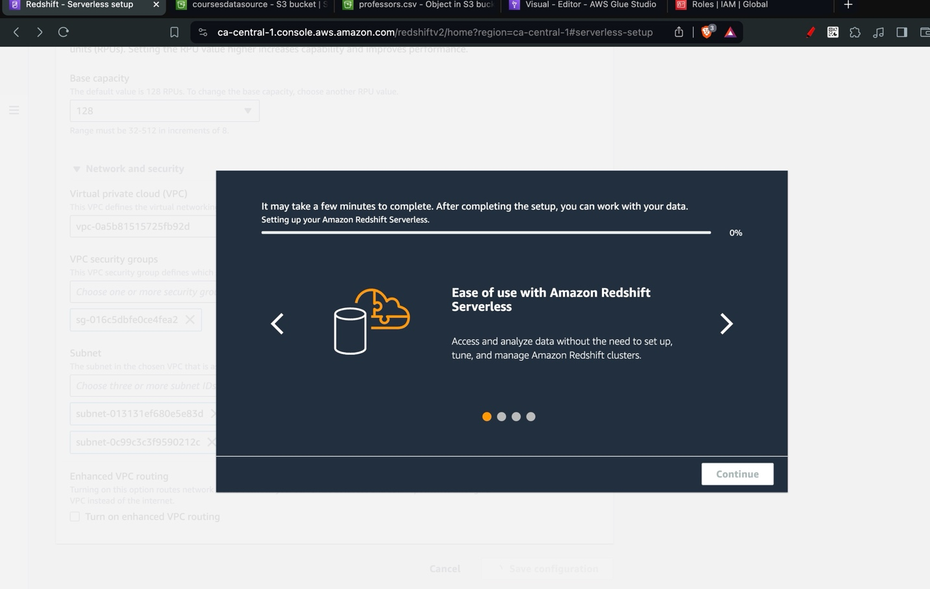

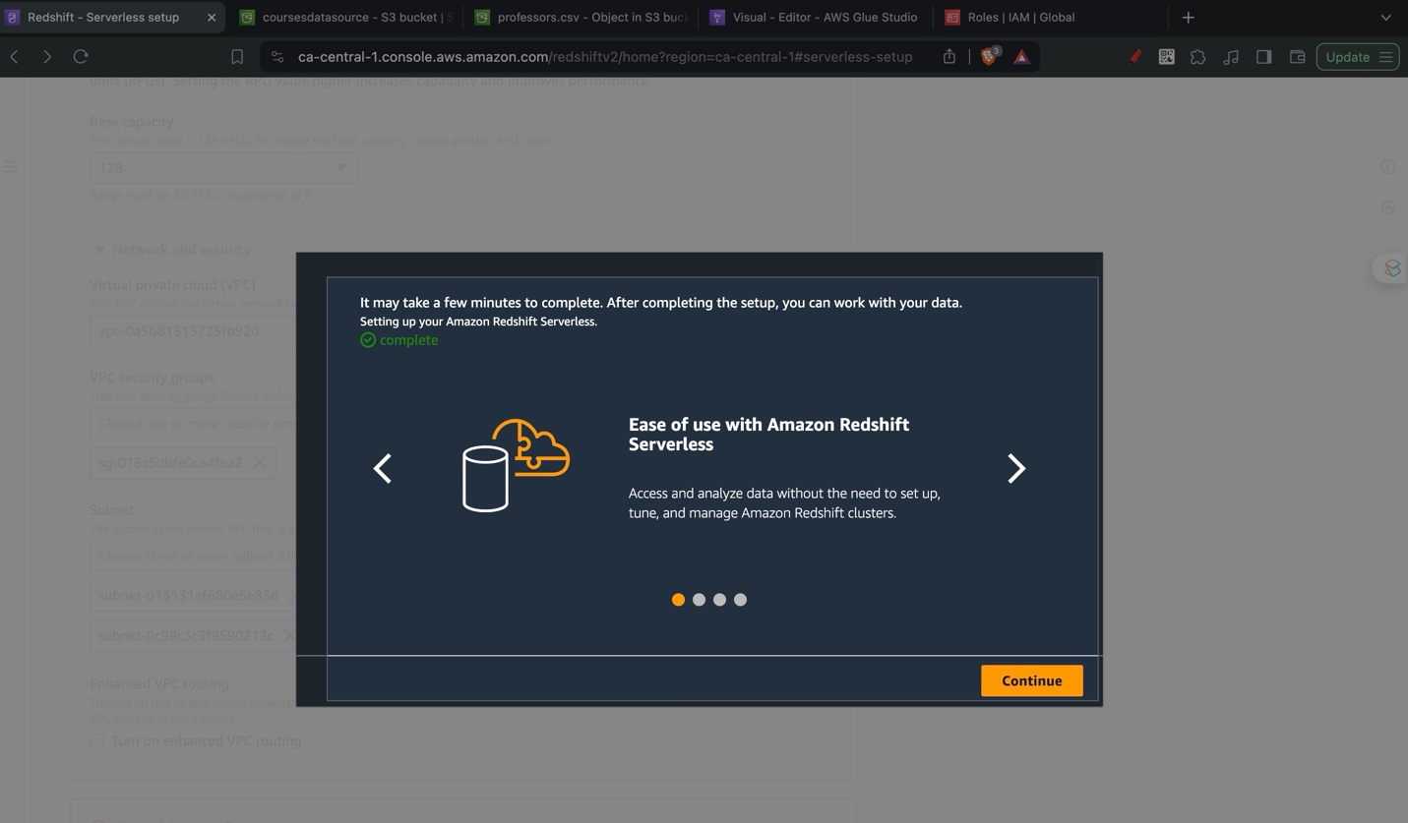

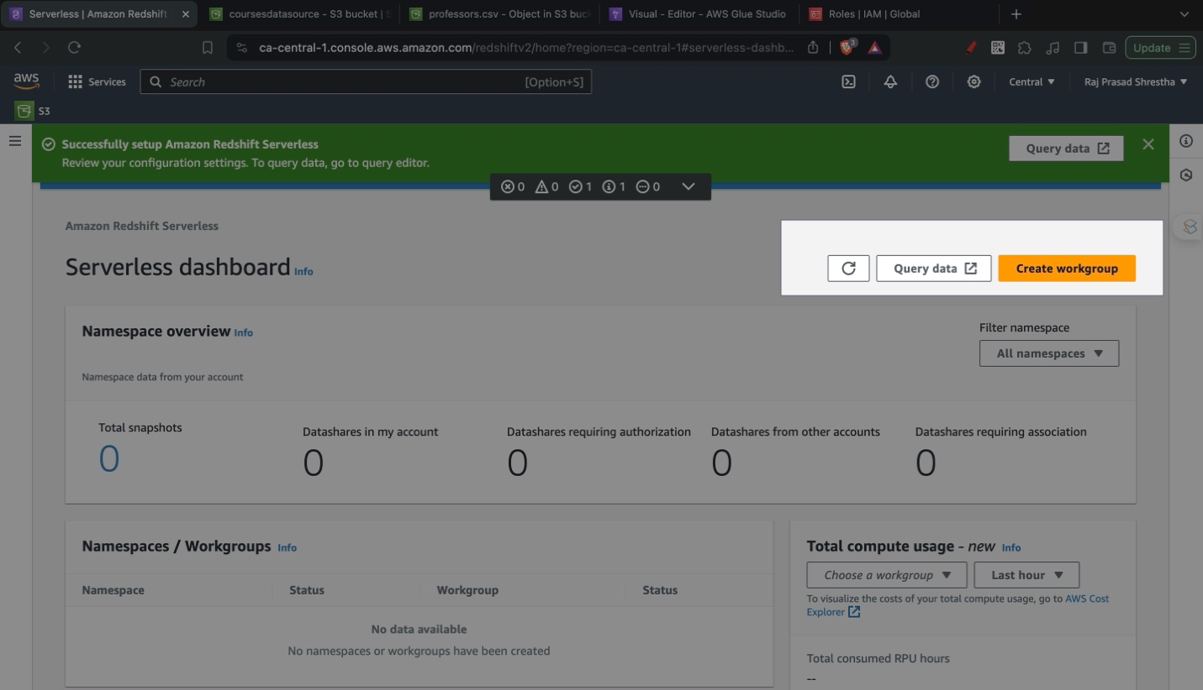

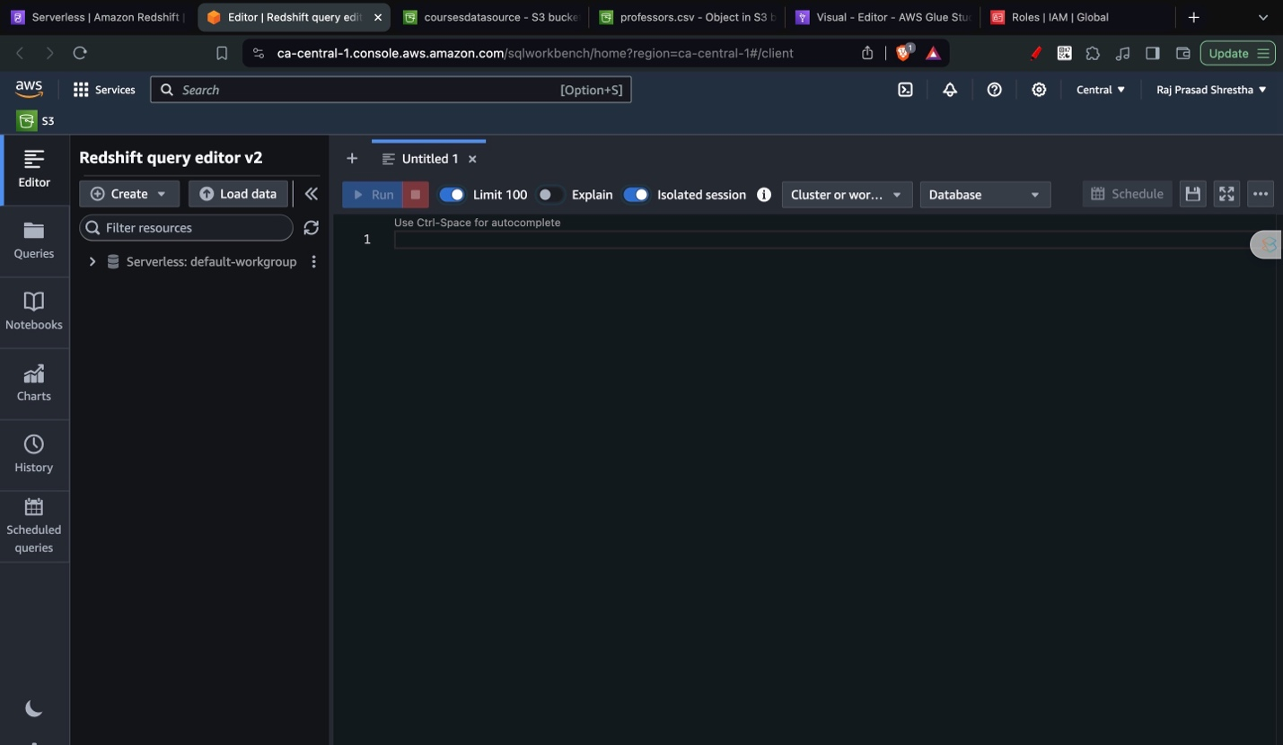





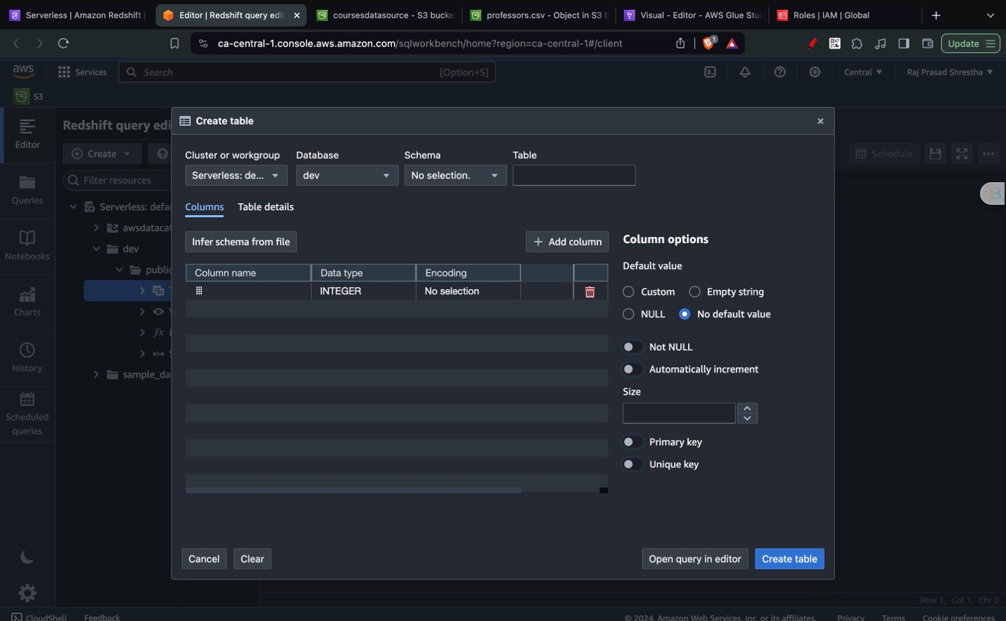

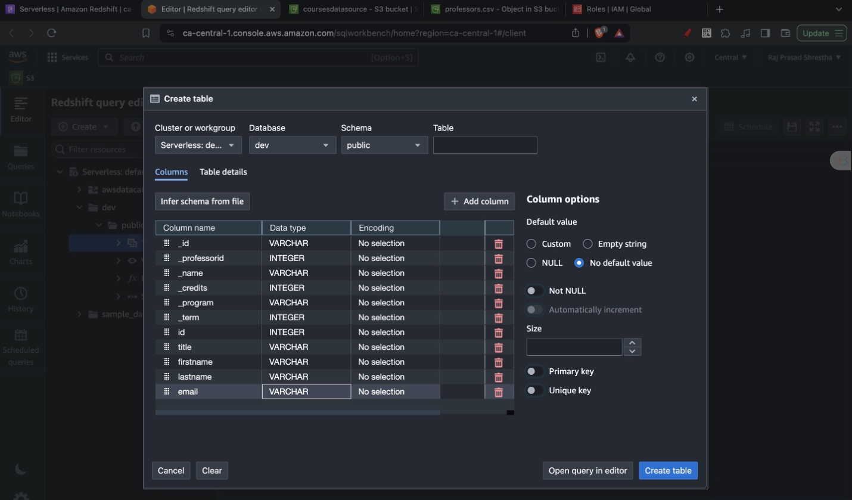

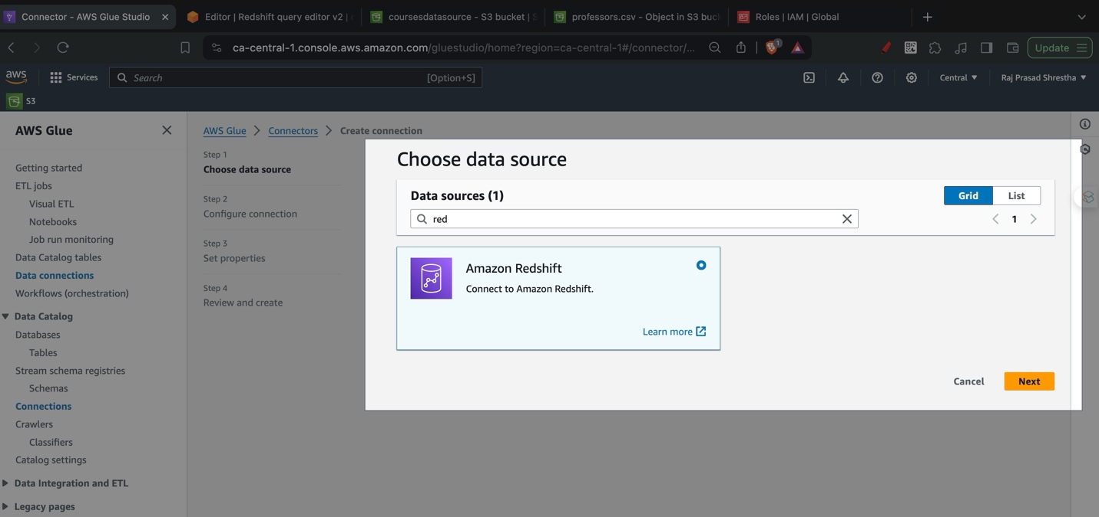

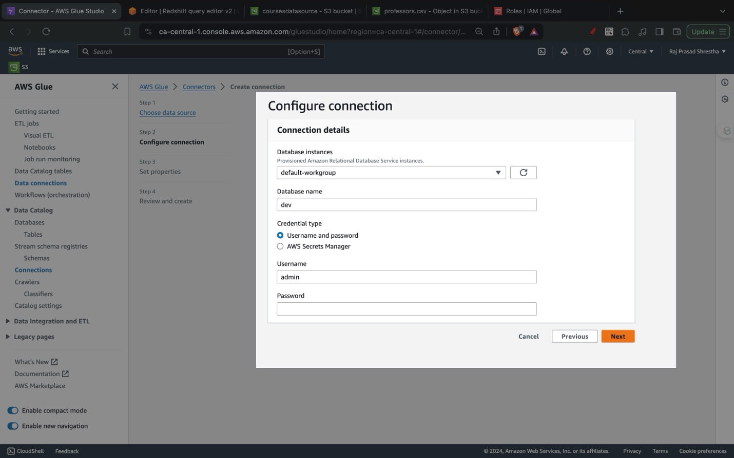

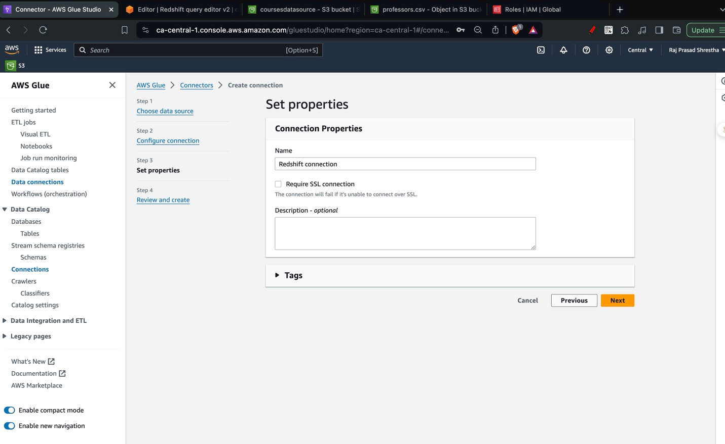

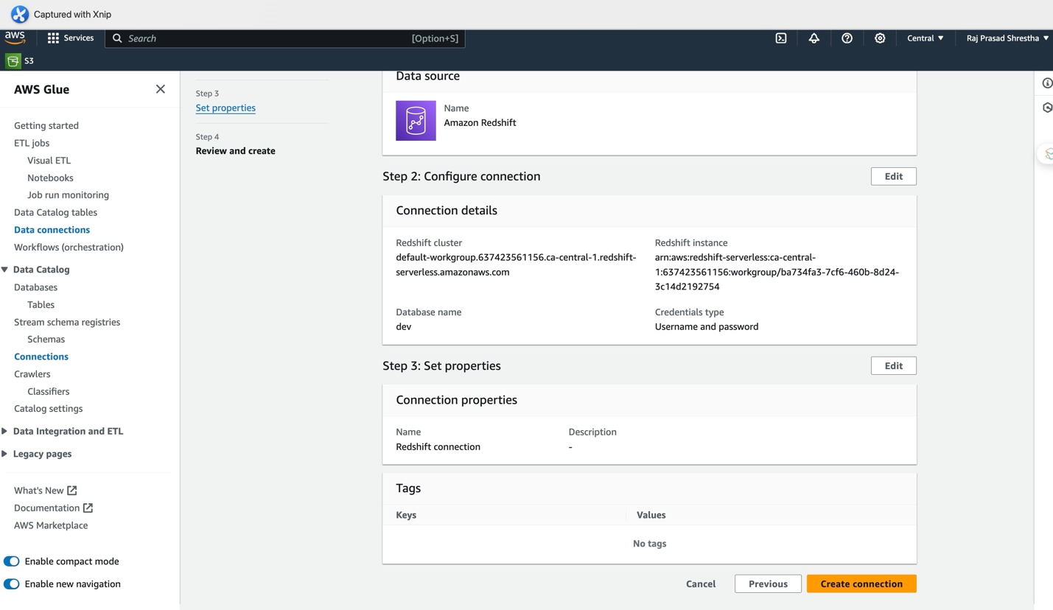

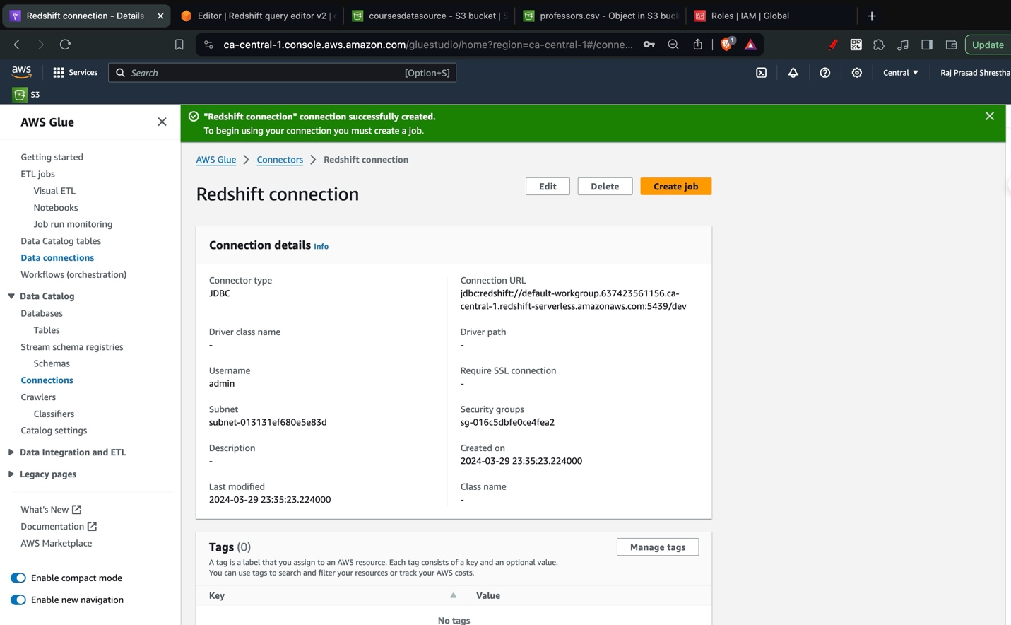

(AWS Glue, n.d.)

# Final Output

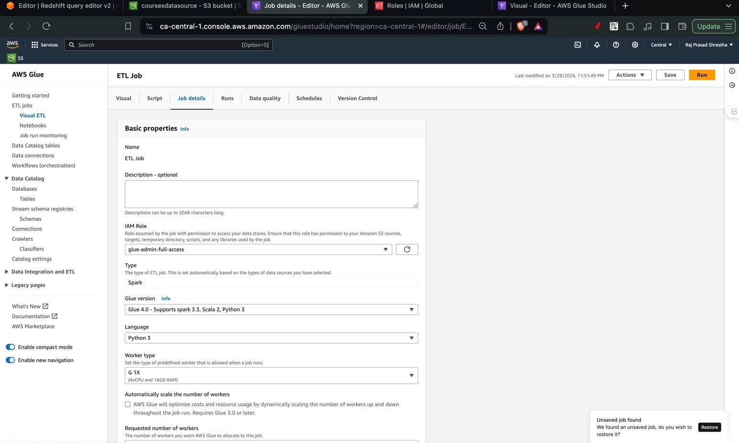

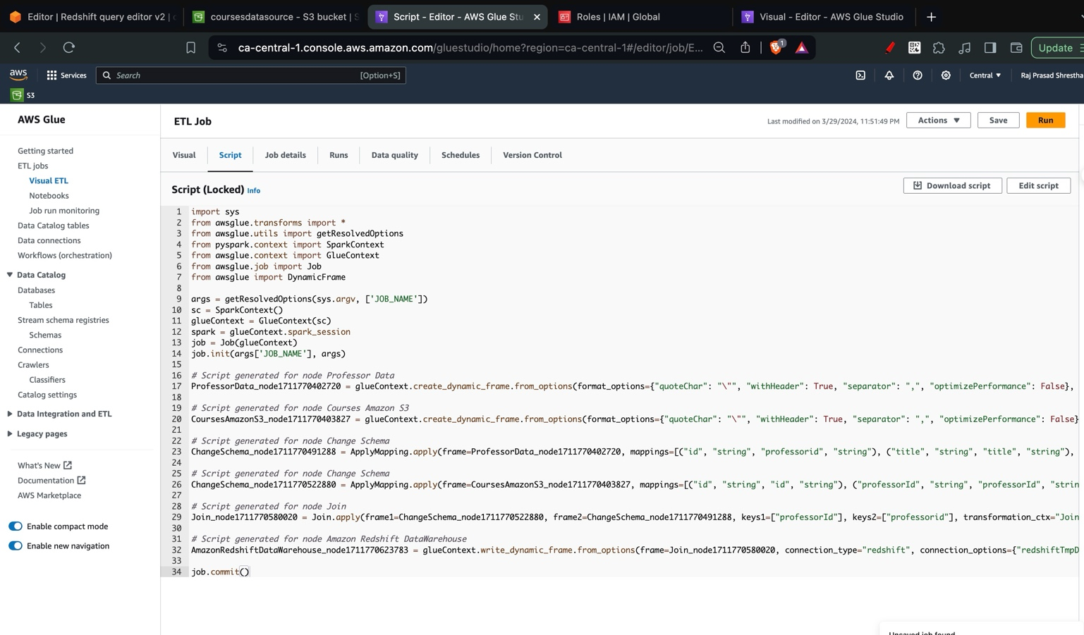

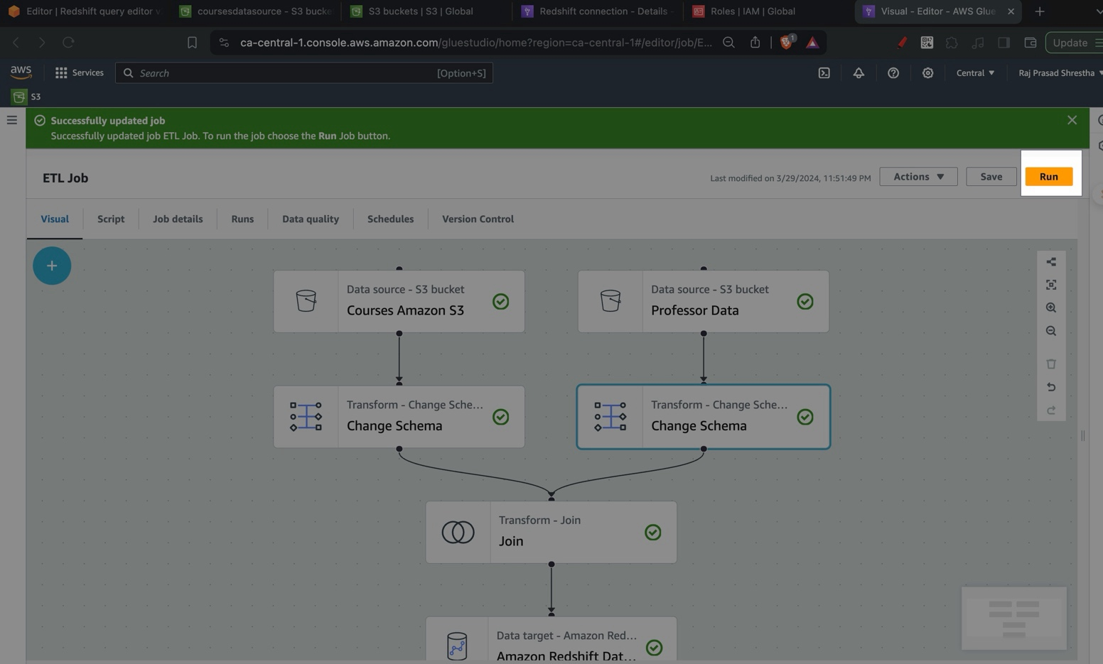

# Works Cited

Amazon Web Services. (n.d.). *What is ETL?* From Amazon: https://aws.amazon.com/what-is/etl/

Oracle. (n.d.). *What Is a Data Warehouse?* From Oracle: https://www.oracle.com/ca-en/database/what-is-a-data-warehouse/

IBM. (n.d.). *What is OLAP (online analytical processing)?* From IBM: https://www.ibm.com/topics/olap

Talend. (n.d.). *Analytical Processing*. From Talend Help: https://help.talend.com/r/en-US/7.3/data-quality-portal-user-guide/analytical-processing

Azure Analysis Services. (n.d.). *Online analytical processing (OLAP)*. From Microsoft: https://learn.microsoft.com/en-us/azure/architecture/data-guide/relational-data/online-analytical-processing

AWS. (n.d.). *AWS Glue*. From Amazon: https://aws.amazon.com/glue/

AWS Glue. (n.d.). *Overview of using AWS Glue*. From Amazon Docs: https://docs.aws.amazon.com/glue/latest/dg/start-console-overview.html

AWS Glue. (n.d.). *Visual ETL with AWS Glue Studio*. From Amazon: https://docs.aws.amazon.com/glue/latest/dg/edit-nodes-chapter.html